Norman Borne Sr.

March 3, 1918 – April 5, 2004

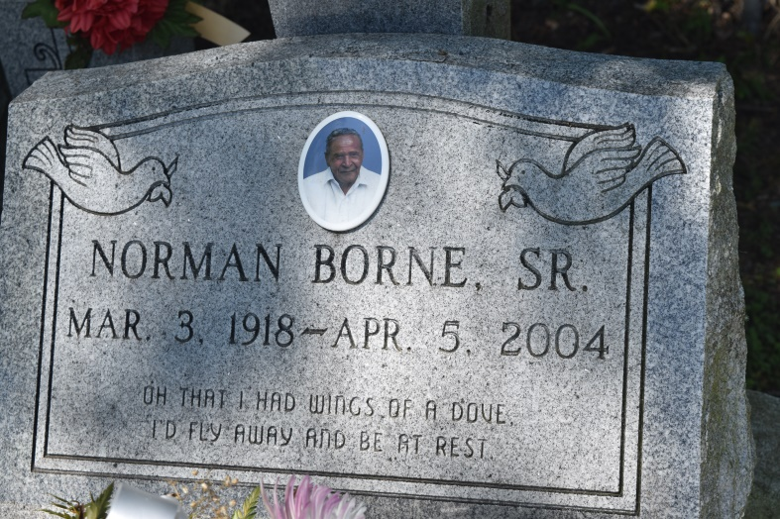

Norman 'Big Boy' Borne of Edgard, LA on Monday, April 5, 2004 at Life Care Hospital, Kenner, LA. Son of the late Urbin and Amy Borne. Beloved husband of Olga Pierre Borne. Father of Gail B. Becnel, Chermaine B. (Donnie) Roybiskie, Roy Michael (Cynthia) Borne, Kurt (Trudy) Borne of Edgard, LA., Dolores B. (Leonard Sr.) Sorapuru of Luling, LA, Norwood (Valerie) Borne, Dr. Madeline (Glenn) Borne of New Orleans, LA., Lloyd Mark (Valerie) Borne of Denver, Colo., Catherine B. Gray of Baton Rouge, LA., Hilton S. (Tammy) Borne of Atlanta, GA. and the late Norman Borne, Jr. Brother of Romalia Jasmin, Jonathan Sr., Ralph Borne, Ophelia Baloney, Eloise Briscoe, and the late Matthew, Isadore, Roland, Christopher Borne and Ollie Hudson. Nephew of Rose Alexander. Godfather of Gregory Brisco and Charles Fiest. Also survived by 29 grandchildren, 12 great grandchildren, a host of nieces, nephews, cousins, friends, sisters and brothers-in-law. A native and resident of Edgard, LA. Age 86 years.  
  
Relatives and friends of the family, also pastors, officers and members of the New Jerusalem B.C., St. John the Baptist Catholic Church, Shiloh B.S., Baton Rouge, LA., Fellowship Missionary Church, New Orleans, LA. and neighboring churches, Employees of St. John Parish School System, Exxon-Mobil, Walgreens, Vision Center of the South, United Airline, Jackson Hewitt-Tax Service, are invited to attend the funeral services on Saturday, April 10, 2004 at 11:00 am from the New Jerusalem B.C., East 6th Street, Edgard, LA., Rev. Joseph Johnson, officiating. Interment church cemetery. Visitation at the church after 9:00 am.  
  
THE BALONEY FUNERAL HOME in charge of arrangements.

Times-Picayune, The (New Orleans, LA) - Friday, April 9, 2004

Contributed by Jane Edson