Ralph Borne Sr.

April 5, 1935 – October 4, 2010

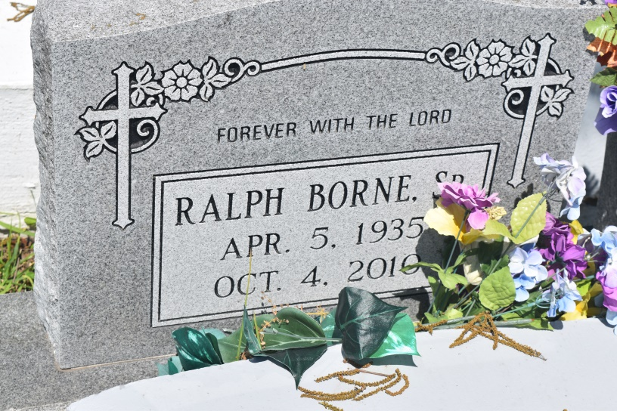

Ralph Borne, Sr. was born April 5, 1935 to the late Urbin and Amy Sylvan Borne in Edgard, LA. He left his earthly home on Monday, October 4, 2010 at the home of his daughter in Edgard, LA at the age of 75. He was a dedicated servant unto the Lord. He attended church weekly and was a faithful member of New Jerusalem until his illness prevented him from doing so.  
 Ralph accepted Christ at an early age and was baptized by the late Rev. C. Washington at the New Jerusalem Baptist Church. He was the former husband of the late Delia Louper Borne. From this union came four children: Ralph Jr. (Antoinette), Killona, LA, Ellington (Beverly), Laplace, LA, Jeffrey Sr. (Charlene), Hahnvillle, LA, and Collette Jackson (Henry), Edgard, LA; seven grandchildren: Patrick Jackson, Megan Jackson, Latricea Tillman, Chase White, Jeffrey Borne, Jr., Charish Borne, Cerenity Borne; and five great-grandchildren: Jamari Tillman, Colby Wells, Kimora Wells, Kyah White and Patrick Jackson, Jr. He was preceded in death by his wife Delia Louper Borne, his siblings Norman Borne Sr., Christopher Borne, Isadore Borne, Matthew Borne, Roland Borne Sr., Jonathon Borne Sr., Ollie Hudson, and Romalis Jasmine. He is survived by his siblings Ophelia Baloney and Bouise Briscoe; a great aunt Rose Alexander: one godchild, and a host of nieces, nephews, cousins and friends. He will be sadly missed by his family and friends.  
 Relatives and friends are invited to the Homegoing Services on Saturday, October 9, 2010 at 11:00am, at New Jerusalem Baptist Church, Edgard, LA, Rev. Frank Johnson Officiating. Visitation from 9:00a.m. until time of service.  
  
Arrangements by The Baloney Funeral Home LLC, Garyville, La. Condolences may be expressed online at www.thebaloneyfuneral [home.com](http://home.com/)

Times-Picayune, The (New Orleans, LA) - Friday, October 8, 2010

Contributed by Jane Edson