Lance Jeffery Bovie

July 5, 1937 – September 2, 2013

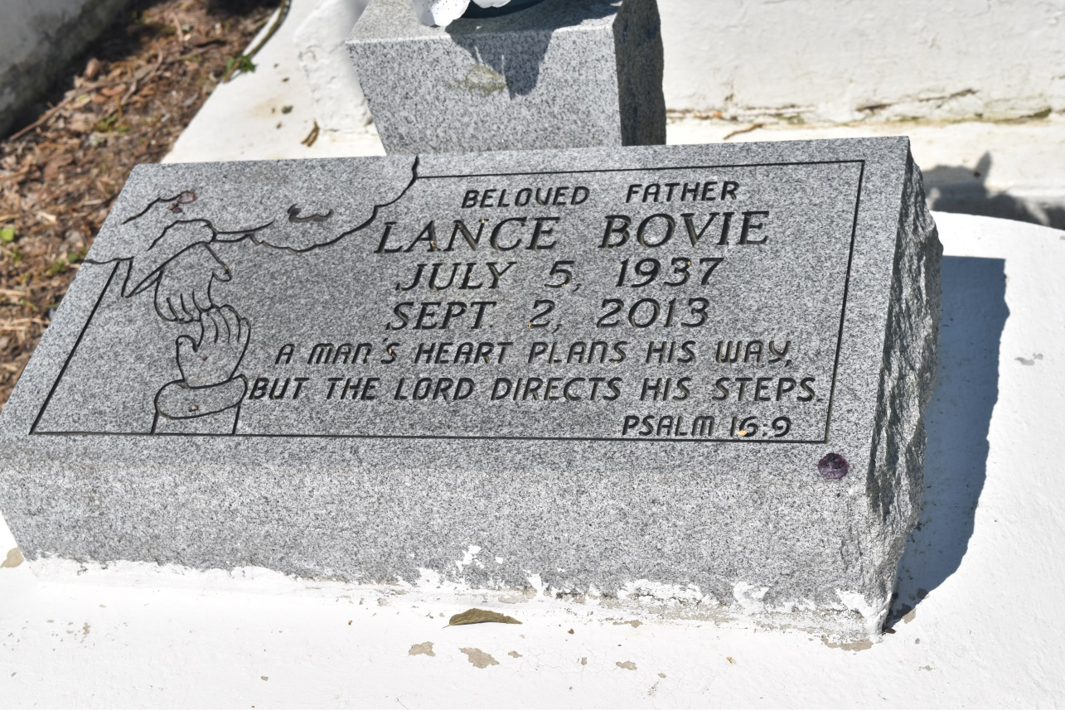

Lance Jeffery "PaPa" Bovie, was called home Monday, September 2, 2013, at the age of 76 years old. Husband of Dolores Roussell. Son of the late Charles and Bernice Bovie. Father of Monica Roussell-Gauthier, Denise Bovie Jackson, Desiree (Dylan) Jackson, Chisarah Bovie and Dominique Fleury. Brother of Ethelyne Bovie Wallace of Houston, Texas, Lottie Mae Barre of Colton, California, Curtis Bovie, Edna Jean Lumar-Sylvain, Lorita Lumar, Tyronne Lumar, Curtis Triggs and Floyd Bradley.  
  
Relatives, friends of the family, The Kansas City Chiefs (NFL) Football Organization, Garyville Elementary Magnet School, Peoples Health, DOW Chemical, Cajun Construction, Pastors and neighboring churches are invited to attend the funeral services on Saturday, September 7, 2013, for 11:00 a.m. at New Jerusalem Baptist Church, 152 E. 6th Street, Edgard, La. Visitation will be from 9:00 a.m. until time of service. Rev. Maurice Tillman will be officiating. Interment will be at the New Jerusalem Baptist Church Cemetery, Edgard, La. Funeral entrusted to The Baloney Funeral Home, LLC., 1905 W. Airline Highway, Laplace, La., 985-224-8460. Condolences can be expressed at [www.baloneyfuneralhome.com](http://www.baloneyfuneralhome.com/).

Times-Picayune, The (New Orleans, LA) - Friday, September 6, 2013

Contributed by Jane Edson