Izel Jamal Dee

May 12, 1980 – November 22, 2002

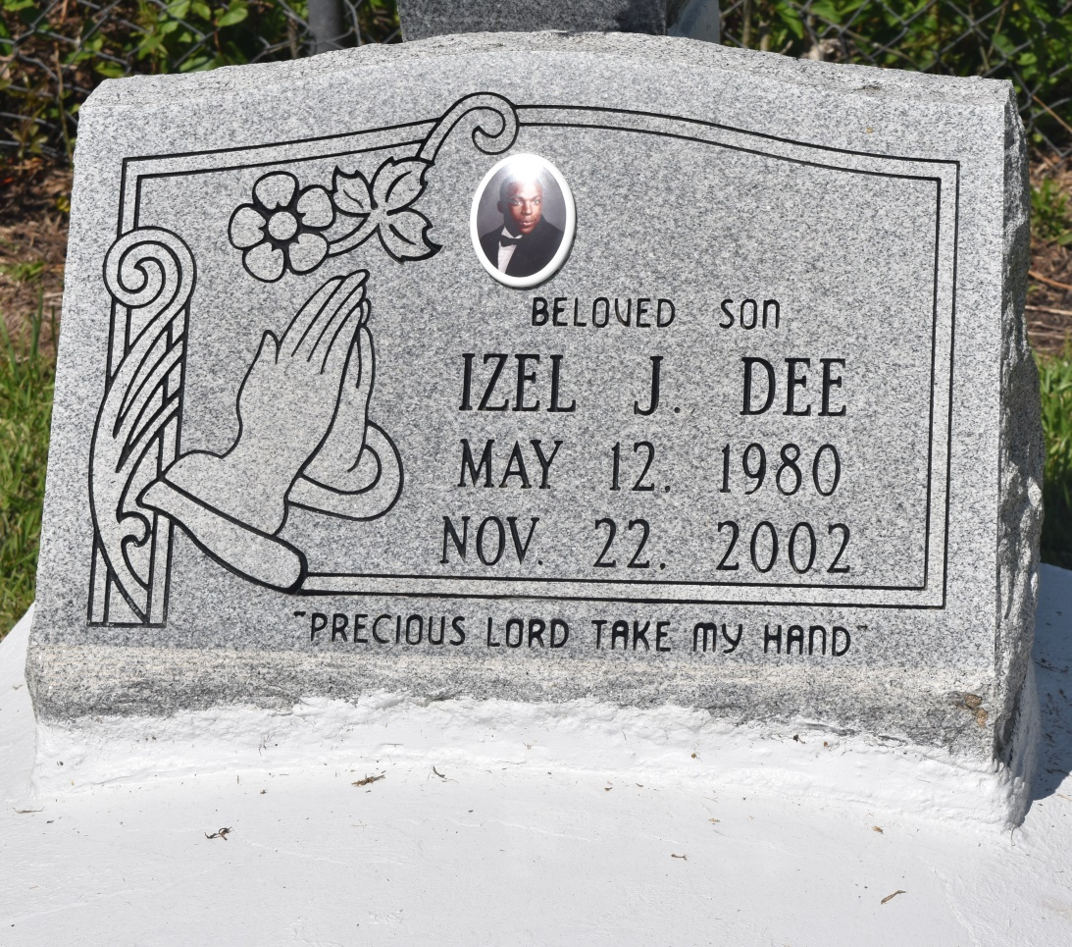

EDGARD - Izel Jamal Dee, 22, a native of Edgard and resident of Atlanta for two years, died Nov. 23. He was the son of David Dee and Joycelyn Borne Thomas; stepson of James Thomas; brother of Chavon LaBranch, Becenda Lockett, Janisha Lee, Heather Edwards, Billy Wilson, Devin LaBranch, David and Joseph Dee III; and stepbrother of Lakesha Brimmer and Ebony, LeJai and Darrien Thomas.  
  
He was the grandchild of Joseph and Mary Dee and Geraldine and the late Lawrence Borne Sr.  
  
He was a student and office manager for The Home Depot in Atlanta.  
  
Services were Nov. 29 at New Jerusalem Baptist Church, Edgard, with interment at the church cemetery.

L'Observateur (La Place, LA) - Friday, December 6, 2002

Contributed by Jane Edson