Elsie (Rousselle) Edwards

February 11, 1918 – May 31, 1999

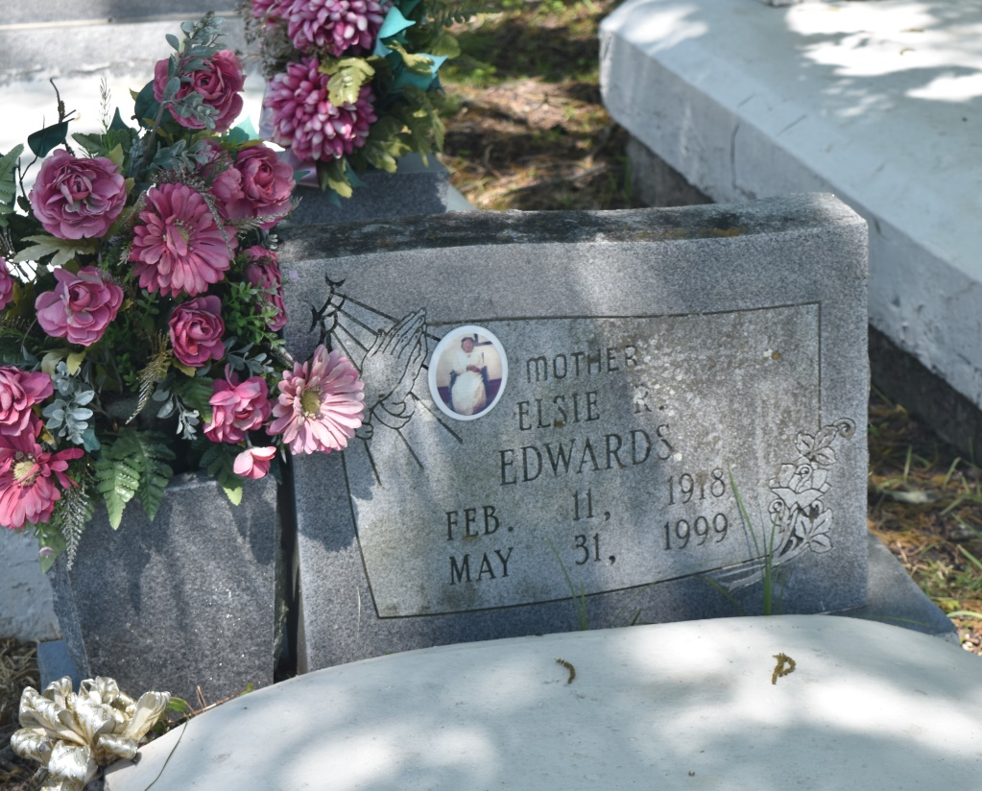

EDGARD - Elsie R. "Dee Dee" Edwards, 81, a native of St. Charles Parish and resident of Edgard, died May 31. She was the wife of the late Ferdinand Edwards Sr. and mother of Florence Brimmer, Elsie Jones, Constance Grows, Earline Allen, Margaret Morris, Gustavia Bailey, Cheryl Louper, Ernestine Tuckerson, Clarence, Tyrone, Allen and Murry Edwards and the late Ferdinand Edwards Jr.  
  
She was also the daughter of the late Augusta Rousselle and Bertha Baker and sister of Lory Rousselle, Elizabeth Scott, John Harris and the late Ernestine Green, Elnora Harris, Gustavia Green, Shirley Dixon and John Rousselle.  
  
She is also survived by 46 grandchildren, 76 great-grandchildren and one great-great-grandchild.  
  
Services are today at noon at New Jerusalem Baptist Church, Edgard, with interment at the church cemetery.

L'Observateur (La Place, LA) - Saturday, June 5, 1999

Contributed by Jane Edson