Kirk Nelson Farnell

February 18, 1921 – November 26, 2004

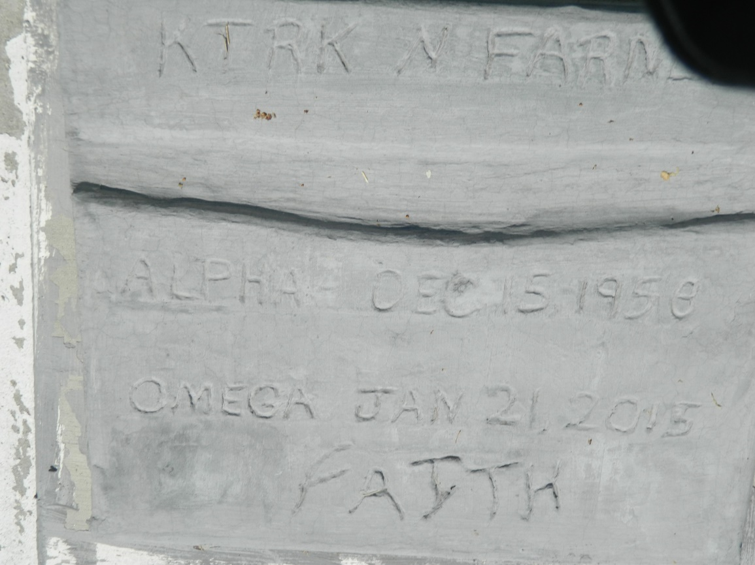

Kirk Nelson Farnell at the age of 56 years departed this earthly life on Tuesday January 27, 2015 at St. Theresa Hospice in Kenner, La. Son of the late Eloise and Luchen Farnell Sr. Beloved Husband of Theresa Farnell. Stepfather of Larry Ranson Jr. Grandfather of Larrineka, Bryia and Clarence. Brother of Kenneth Farnell, Vernon (Kat), James (Troshane), Wayne (Gail), Valarie, Mary, and Latesa Farnell. Brother-in-law of Madeline Davis, Haston Davis and Helston Davis. A devoted friend of Eric Griffin and Frankie Austin. Also survived by a host of aunts, uncles, nieces, nephews, other relatives and friends.  
  
Pastors, Officers and Members of Children of Israel Baptist Church of Killona, La., New Hope Baptist Church, Canaan Baptist Church, and all neighboring churches, Employees of Luling Living Center and Hospice Compassion are invited to attend the Home-going celebration on Saturday February 7, 2015 at 11:00 am at the Children of Israel Baptist Church 263 Killona Dr., Killona, La. Rev. Austin Dennis officiating. Interment in New Jerusalem Baptist Church Cemetery of Edgard, La. Visitation from the above name church from 9:00am until service time. Bardell's Mortuary of Mt. Airy, La. in charge. Information: 985-535-6837.

Times-Picayune, The (New Orleans, LA) - Friday, February 6, 2015

Contributed by Jane Edson