Suzanne (Bovie) Gaudet

November 18, 1946 – November 20, 2008

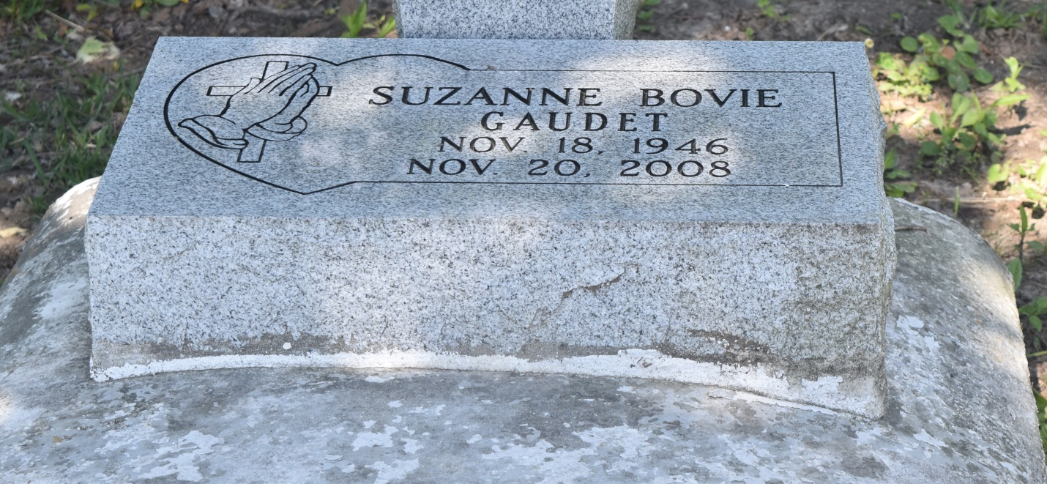

Suzanne Bovie Gaudet, of Edgard, on Tuesday, November 20, 2008, at her home she heard God's voice and answered the call. Daughter of the late Charles and Bernice Bovie. Wife of the late Moriel Gaudet Sr. Mother of Suzette Walker (Willie) of Garyville, Moriel Gaudet Jr. (Chandra) of New Sarpy, Kyle Gaudet (Dinah) of College Park, Ga., Tricia Turner (Wade) of Edgard, and Dominique Fleury of Edgard. Sister of Ethylene Wallace, Lottie Mae Barre of Upland, Calif., Lorita Lumar of Egard, Lance and Curtis Bovie, Curtis Triggs, Tyronne Lumar of Edgard, Max Costello of Chicago, Ill., Floyd Bradley of St. Rose, the late Charles Jr. and Leo Bovie and Gene Triggs. Also survived by 10 grandchildren, a host of nieces, nephews, cousins and friends. Daughter-in-law of Clara and the late Emile Gaudet.  
  
Visitation and services were held on Monday, November 24, at the New Jerusalem B.C. in Edgard. Interment in Church Cemetery.

L'Observateur (La Place, LA) - Wednesday, November 26, 2008

Contributed by Jane Edson