Ellis Grows Sr.

October 8, 1952 – February 15, 2002

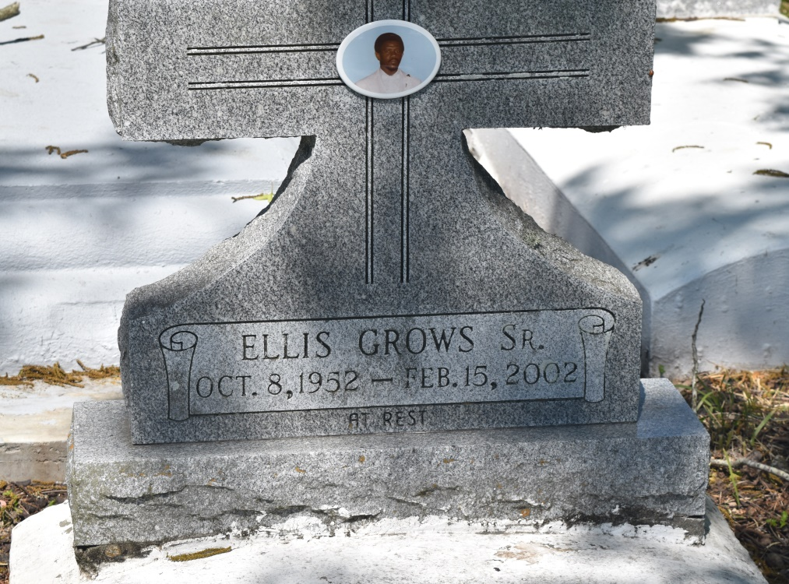

Ellis (Twenty-Seven) Grows, Sr. of Edgard, La. at River Parish Hospital, Laplace, La. on Friday, Feb. 15, 2002. Husband of Constance Edwards Grows. Son of the late Louis and Cora Grows. Father of Ellis Jr., Tyler and J'Marrco Grows. Brother of Walter Grows Sr., Lawrence Grows Sr., Amelia Narcisse, Evelyn Grows, Eloise Stockman, Dorothy Smith, Eula Mae Narcisse, Annie Mae Populus, Francis Williams and the late Morris, Oscar, and Melvin Grows. Also survived by a host of aunts, uncles, nieces, nephews, sisters and brothers-in-law, other relatives and friends. A native and resident of Edgard, La. Age 49 years.  
  
Relatives and friends of the family, also Pastor, Officers and members of the New Jerusalem B.C., 2ND African B.C., Greater New St. Peter B.C. and neighboring churches. Employees of Avondale Shipyards, U.S.D.A.-F.G.I.S., L.W. Higgins High School, Henry Ford Middle School are invited to attend the Funeral Services on Wednesday, February 20, 2002 at 11:00 AM from the New Jerusalem B.C. Edgard, La. Rev. Joseph Johnson, officiating. Interment Church Cemetery. Visitation at the church after 8:00 AM - (NO WAKE)  
  
THE BALONEY FUNERAL HOME IN CHARGE OF ARRANGEMENTS

Times-Picayune, The (New Orleans, LA) - Tuesday, February 19, 2002

Contributed by Jane Edson