Laverne (Jasmine) Jack

October 9, 1950 – April 24, 2009

Kalantha M. Jackson

July 4, 1962 – March 1, 2005

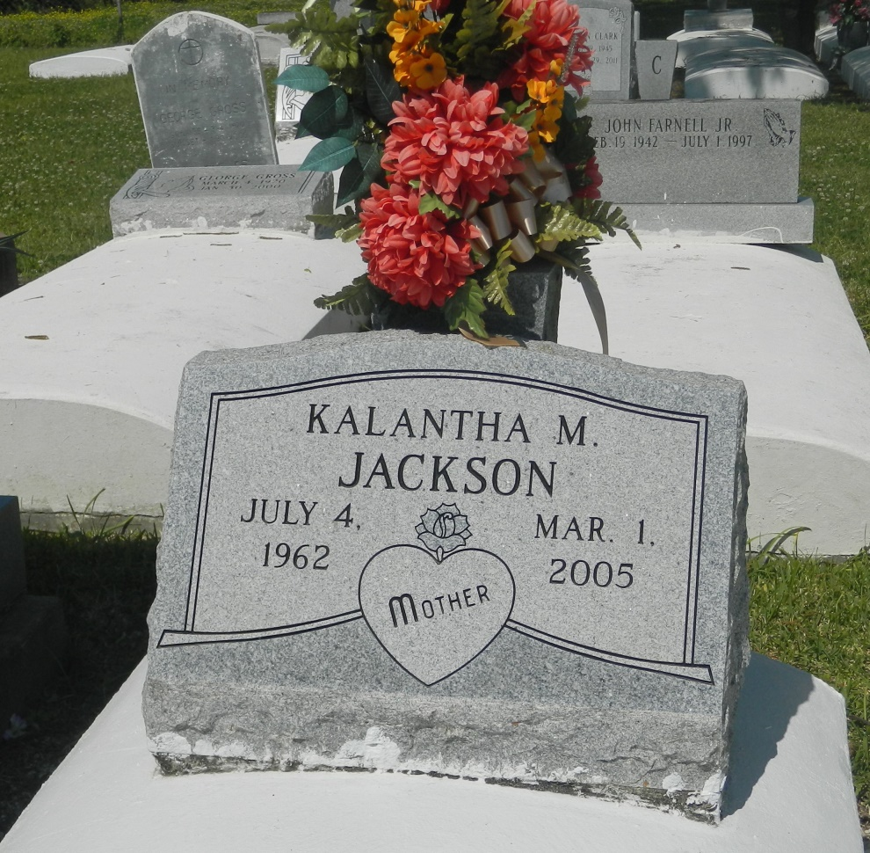

Kalantha "Cocoa" Jackson, a former board member of the St. John the Baptist Parish Housing Authority, died Tuesday of a heart attack at St. James Parish Hospital. She was 42. Ms. Jackson was a lifelong resident of Edgard. She had served as the resident council member for the parish housing authority. Survivors include a son, Theron Clark; a sister, D'Andra Joseph; and a grandchild. A funeral will be held Saturday at 11 am. at New Jerusalem Baptist Church on East Sixth Street in Edgard. Visitation will begin at 9 a.m. Burial will be in the church cemetery. The Baloney Funeral Home is in charge of the arrangements.

Times-Picayune, The (New Orleans, LA) - Friday, March 4, 2005

Contributed by Jane Edson