Adrian Lumar Jr.

March 31, 1939 - September 02, 2017

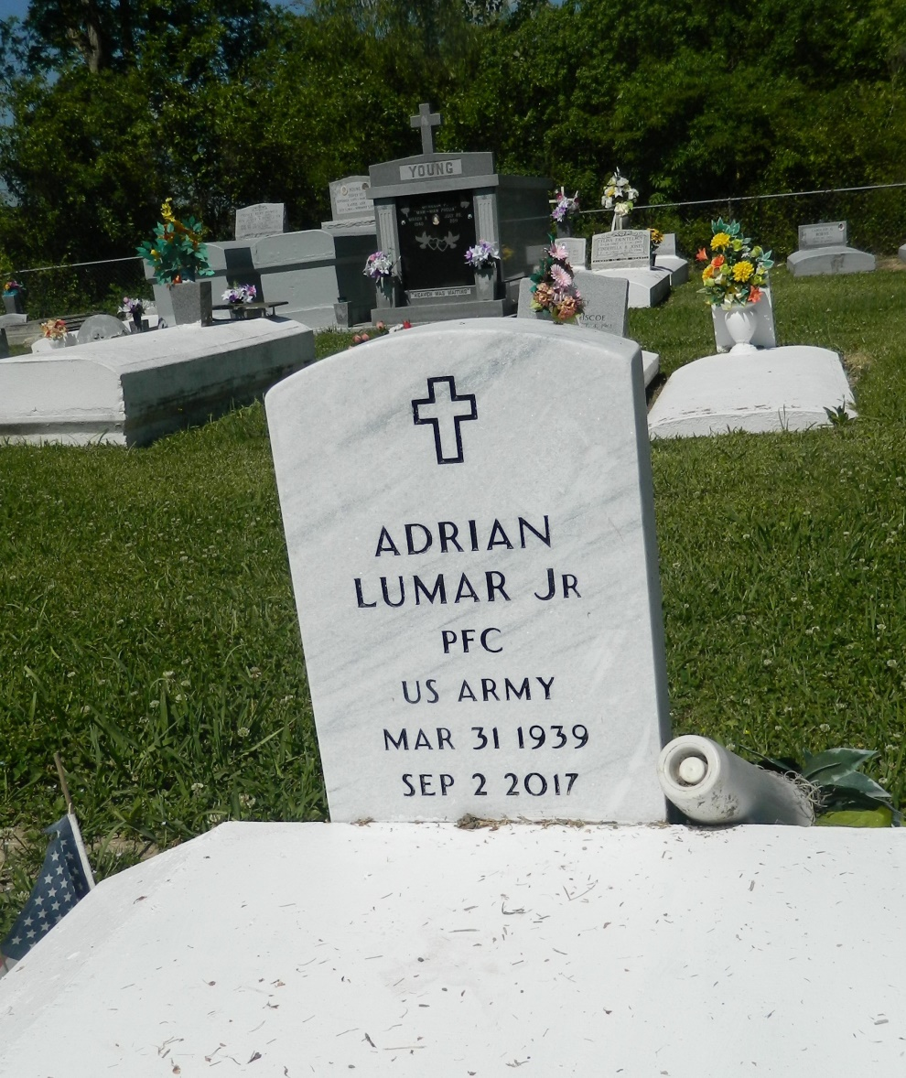

Adrian Lumar, Jr. of Edgard, LA entered into eternal rest on Saturday, September 2, 2017 at the age of 78. Beloved husband of Florence Lumar for 53 years. Father of Thaddeus Lumar (Shannon) of Harker Heights, TX, Dorian Lumar (Rickie) and Carmen Lumar of Edgard, LA.   
Grandfather of Dashon Nicholson (Randall), Rickiel, Rico, Tyrell, Thaddeus Jr. and Isaiah Lumar, and Shalyn and Shanya Manadier. He also leaves, four greatgrandchildren; a host of nieces, nephews, other relatives and friends. Lifetime friend of Jessie Johnson and Jerry Savoie. He was a former employee of American Minority Enterprise. He was preceded in death by his parents Elizabeth and Adrain Lumar Sr, brother Fonerias, Sterling, Curtis, Cleveland, and stepsister Alice White. Neighboring communities of Edgard, RPM (Dupont), and the Veteran’s Administration Service of Central TX are invited to attend a Celebration of Life on Thursday, September 7, 2017 at Historic Bethlehem Baptist Church, 14989 River Road, Hahnville, LA. Rev. Rodney L. Johnson Pastor & Officiant. Visitation begins at 9:00 am followed by 11:00 am Services. Interment to follow at New Jerusalem Baptist Church Cemetery, Edgard, La. Final care entrusted to Treasures of Life Funeral Service 315 East Airline Hwy. Gramercy La. 70052.  
"When someone you love becomes a memory, that memory becomes a TREASURE!"

Obittree.com (accessed 6/25/2018)