Charles Anthony Samuel

July 9, 1965 - December 19, 2022

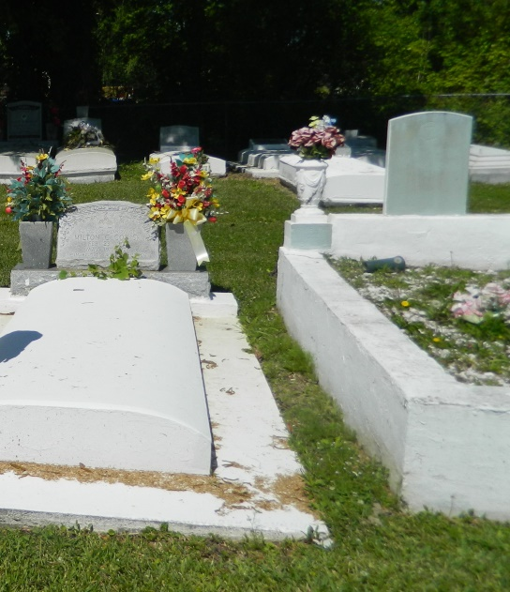

Charles Anthony Samuel departed this life peacefully on Monday, December 19, 2022, at the age of 57. He was born in Denver, CO and at the age of seven, his family relocated to Edgard, LA, where he was raised. In late 2019 he moved to Pembroke, FL where he resided at the time of his death.  
 He was the son of the late Anthony J. and Linda A. Samuel; the beloved husband of Kimberly Dianne Samuel; father of Kimmeka Stoner, Kierra Samuel, and Charles Anthony Samuel II; two bonus sons Doni II and Dion Robinson. Loving grandfather of Naasir Johnson and brother of Racquel (Keith) Bruce and uncle of Erris Bruce.  
Charles leaves to forever cherish his memories his beloved wife Kimberly Dianne; his five children, his one beloved grandchild; one loving sister, brother-in-law, and niece; mother -in- law Mae Gordon; sister-in-law Bridgette Dennis; his Godchildren, Mark Wright Jr. and Vickie Roberts; devoted friends, Darryl Butler, Wade Turner, Todd Edward, and Shelton Roberts; a loving host of uncles, aunts, cousins, and friends.  
 He was preceded in death by his parents, grandparents Steve Samuel, Artemese and Wilbert Jacob, Thomas and Lillian Jasmine; nine aunts and two uncles.  
 Relatives and friends are invited to attend a celebration of life on Saturday December 31, 2022, at New Jerusalem Baptist Church, 152 E. 6th St. Edgard, LA 70049. Visitation 8am-10 am. Service begins at 10am. Interment to follow at New Jerusalem Baptist Church Cemetery. Final care and professional services entrusted to Treasures of Life Funeral Services, 315 E. Airline Hwy., Gramercy, LA 70052.

Treasures of Life Funeral Services, Gramercy, LA