Hattie (Washington) Sanders
March 23, 1919 – December 31, 1999
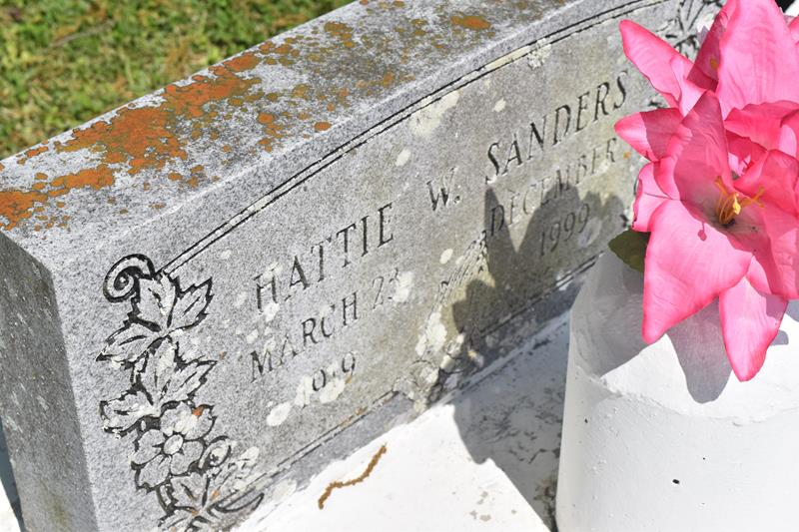

EDGARD – Hattie Washington Sanders, 80, a native of Edgard and resident of Reserve, died Dec. 31. She was the wife of the late Harry Sanders Sr., mother of Ruby Griffin, Harry Jr. “Billy,” Rosiland, Michael and David Sanders and the late Ora Lee Jack and Leroy Sanders Sr. and step-mother of Mable Sandy.
She was also the daughter of the late Emile and Harriet Washington and sister of Rose Bolden, Veola Searcy, Emile Washington and the late Semoria Rainey, Yvonne Brignac, Hazel August and Cecile, Thelma, Emma, Maude and Albert Washington.
She is also survived by 17 grandchildren and nine great-grandchildren.
Services are today at 11 a.m. at New Jerusalem Baptist Church, Edgard, with interment at the church cemetery. Visitation starts at 10 a.m.
L’Observateur, LaPlace, Louisiana
January 5, 2000

