Mildred Smith
September 26, 1938 - August 31, 2023
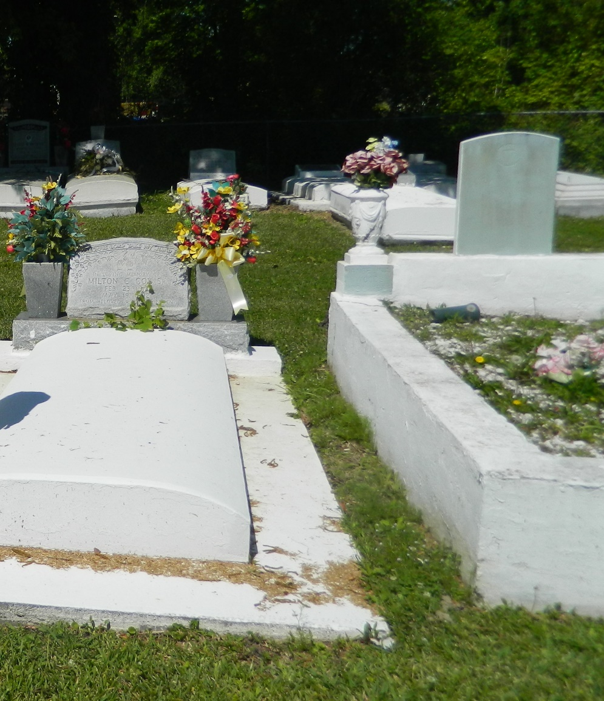

Mildred Smith was born on Sept. 26, 1938, and passed away peacefully on August 3, 2023, at the age of 84. She was the daughter of the late Rev. Landry C. Smith and Victoria Herbert Smith. Mildred is survived by one daughter: Debra (Bernard) Howard; grandchildren: Asantra Mollaire, Teommi Davenport, Rayon Smith, Amber Howard, Damond Smith, LeVar Goudia, and Trevor Smith; great-grandchildren: LaRon , Janiah , Gia , Jarrien , J’Kyren , Emmitt III, Ayden, Ava and Hasan Jr.; great-great-grandchildren: Kerrione and Zuri; daughter-in-law: Valerie Smith; son-in-law: Kevin Grows; Godchild: Wilbert Wayne Milton, and a host of nieces, nephews, relatives and friends.
She was proceeded in death by her daughters: Deyon Smith Benjamin, Bonnie Smith Grows; one son: Byron Anthony Smith, Sr.; and one grandson: Byron Anthony Smith, Jr.
She was employed by St. John the Baptist Parish School Board where she retired in 2002. Mildred loved to praise GOD, walking her lil strut from the back of the church while serving on the Usher Board faithfully. She was an amazing cook who loved her family. She also loved spending time on the phone with her friends, and going to the fitness center.
A public walk-through visitation will be held on Friday, September 8, 2023, at Treasures of Life Funeral Services, 315 E. Airline Hwy., Gramercy, LA 70052 from 5PM- 7PM. Family and friends, along with employees of St. John the Baptist School Board and Walmart, and all neighboring churches are invited to attend the funeral services that will be held on Saturday September 9, 2023, at New Jerusalem Baptist Church, 152 East 6th Street Edgard, LA 70049 beginning at 2PM. Visitation will begin at 1PM until the start of the service. Pastor K. Maurice Tillman, officiating. Interment to follow at New Jerusalem Baptist Church Cemetery.

Treasures of Life Funeral Services, Gramercy, Louisiana
September 8, 2023

