Carl David Valentine
May 8, 1965 – September 22, 2023

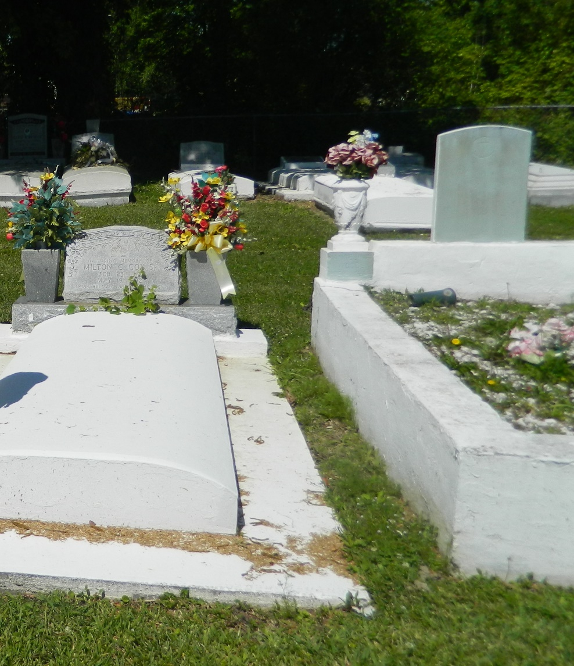

On the morning of September 22, 2023, the angel of death summoned our beloved, Carl “Crip” David Valentine, while at Chateau Terrebonne Health Care, and he entered into the eternal presence of our Heavenly Father.
Carl was born on May 8, 1965 to Audrey L. Valentine and the late Augufur Valentine. He accepted the Lord as his Savior and was baptized at a young age. He later became a member of Second African Baptist Church, in Edgard, under the leadership of Reverend Clarence Z. Mollaire, Sr.
Although he was challenged physically throughout the course of his life & did a lot of his studies by way of homeschooling, when he was able, Carl attended West St. John High & was a member of the Mighty Class of 1986.
On November 25, 2000, Carl was united in Holy Matrimony to Stacey D. Stewart. To know Carl was to absolutely love him. Humble, fun-loving, patient & kind are just a few words to describe his delightful character. He was adored by everyone he came in contact with, but especially by everyone in Lewisville. He spent a lot of his spare time in the company of family & friends out in the yard doing what he did best - drinking his Bud Ice & BARBECUING. If you never got a chance to taste anything off of his grill, you truly missed out. Carl was known as the King of Checkers. It has been said that the only person who could beat him at his own game was his good buddy & pal, Barry Chopin (Doo-Doo). He was also a die-hard fan of the Dallas Cowboys & would never miss the chance of watching them in action on tv.
He leaves to mourn his departure and cherish his memories, his estranged wife, Stacey D. Stewart-Valentine; mother, Audrey Valentine; aunts, Catherine (Walter) Rybiskie, Joyce (Derek) Alexis, Sandra (Gerald) Lewis, Iris Howard (Lionel) Lewis and Cenovia (Azerius, Jr.) Valentine; uncles, Glenn Lewis, Shelton (Brenda) Valentine, Jacob Valentine, George (Jill) Valentine, Derek Alexis and Wilbert Milton; two sisters-in-law, Keeva (Roger) Nichols and Kema (Jeffery) Matthews; two brothers-in law, Roger Nichols, Sr. and Jeffery Matthews, Sr.; Godparents, Deselle Milton-Gustain and Wayne Milton; three nephews, two nieces, one great-niece and a host of cousins, dear friends and neighbors.
Family members preceding Carl in death are his father, Augufur Valentine; maternal grandmother, Leontine Lewis; paternal grandparents, Alberta Valentine and Azerius Valentine, Sr.; uncles, Robert Lewis, Gerald Lewis, Lionel Lewis, Walter Rybiskie and Azerius Valentine, Jr.; aunts, Juanita Valentine, Shirley Valentine-Coleman, Jill Valentine, Dorothy Milton and Brenda Valentine and mother-in-law Christine Stewart.
A celebration of life honoring Carl David Valentine will be held on Saturday, September 30, 2023, at Second African Baptist Church, 136 W 3rd Street, Edgard, La 70049. Visitation will be from 9-11 a.m. Service will begin at 11 a.m. Interment to follow at New Jerusalem Baptist Church, 152 E. 6th Street, Edgard, La 70049.

Treasures of Life Funeral Services, Gramercy, Louisiana
September 29, 2023

