Ella (Farnell) Wallace

January 11, 1919 – June 29, 2002

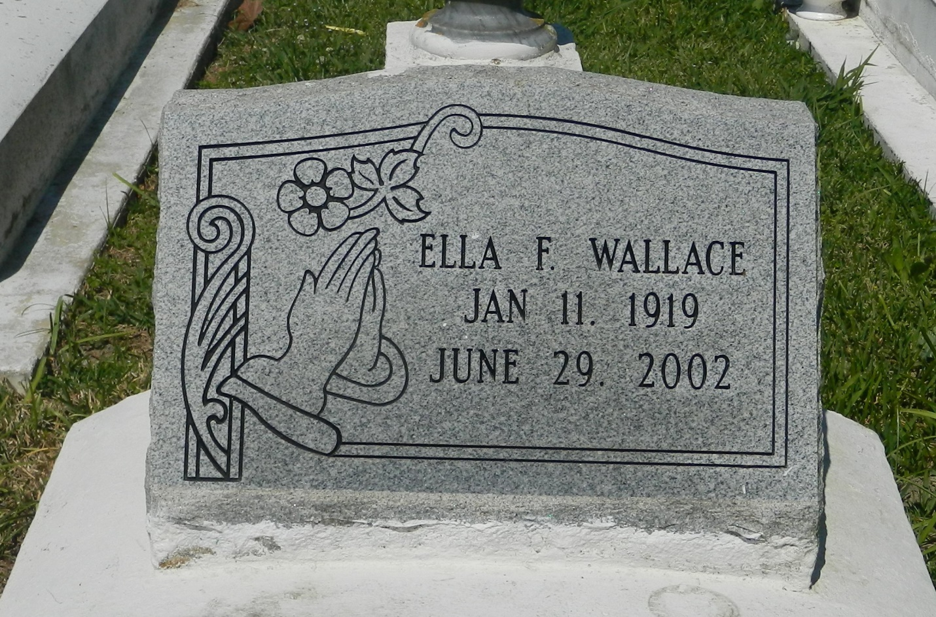

Ella Farnell Wallace, a retired seamstress, died June 29 of heart disease at her home. She was 83. Mrs. Wallace was born in Edgard and lived for several years in New Orleans before returning to Edgard. Survivors include her husband, Louis Wallace; a sister, Julia Grows; and a brother, Cleveland Farnell. A funeral will be held Saturday at noon at New Jerusalem Baptist Church in Edgard. Visitation will begin at 9 a.m. Burial will be in the church cemetery. The Baloney Funeral Home is in charge of arrangements.

Times-Picayune, The (New Orleans, LA) - Thursday, July 4, 2002

Contributed by Jane Edson