Orelia (Jasmine) Wright

February 22, 1934 – September 29, 2016

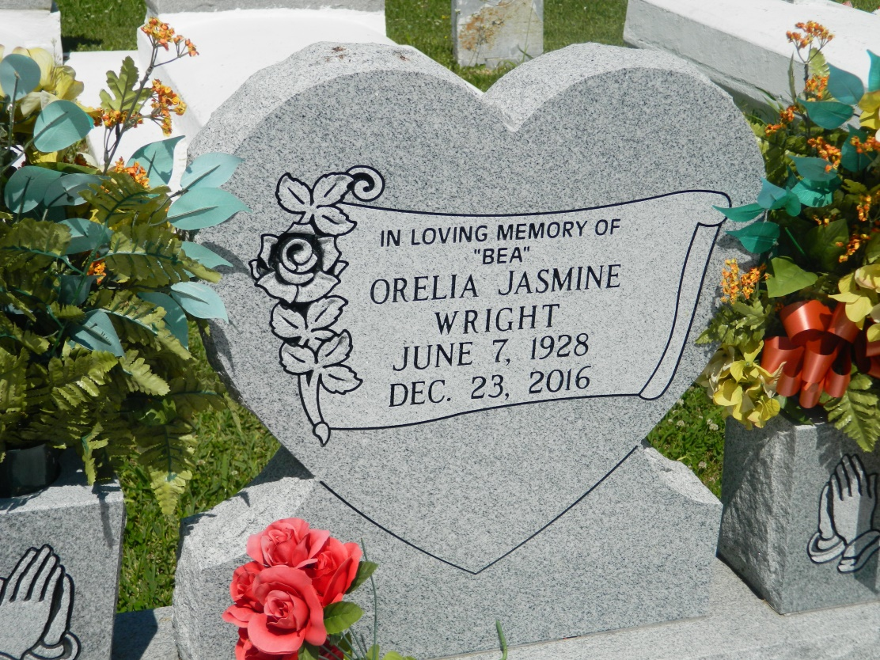

Orelia Jasmine Wright, a native of Edgard, LA, departed this life on Friday, December 23, 2016. Daughter of the late Thomas and Lillian Jasmine. Mother of Betty Franklin (Zachary, Sr.), John Allen Wright (Tammy), Valerie Torregano (Ronnie), Alicia Wright, Mark Wright (JoMarietta), and David Wright. Sister of Enola Allen, Shirley Thomas, Marion Feist, Myrtle Walker, Thomas Jasmine, Alton Jasmine, Nathaniel Jasmine, Madeline Bourgeois, and Joslyn Gastearl. Preceded in death by husband John Wright, Sr., son Antoine Jasmine and daughter, Laverne Jack (Russell, Sr.); sisters Janice Lumar, Linda Samuel and Cynthia Tompkins. She is also survived by twenty grandchildren and caretaker Demetrius Williams, along with a host of other relatives and friends. Relatives, friends and employees of St. John the Baptist Parish School System are invited to attend the funeral services held at New Jerusalem Baptist Church, 152 East 6th St., Edgard, LA on Saturday, December 31, 2016 at 11:00am. Visitation begins at 9:00am. Rev. K. Maurice Tillman, officiating. Interment in the church cemetery. A gathering of family and friends will be on Friday, December 30, 2016 from 4:00pm – 6:00pm at Treasures of Life-Center for Life Funeral Services, who have been entrusted with her final care. 315 E. Airline Hwy, Gramercy, LA 70052.

"When someone you love becomes a memory, that memory becomes a TREASURE!"

Published in TheNewOrleansAdvocate.com from Dec. 29 to Dec. 31, 2016

Legacy.com (accessed 6/26/2018)