Leona (Millet) Batiste

February 1, 1920 – March 15, 2003

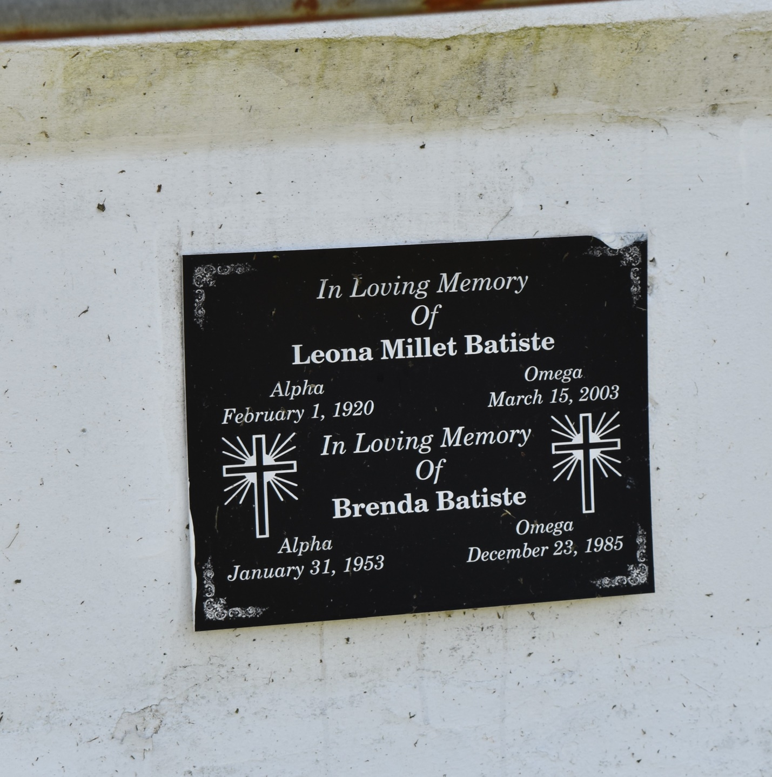

Leona Millet Batiste at Kindred Hospital, New Orleans, LA. on Saturday, March 15, 2003. Daughter of the late Orelia Alger and Adam Millet. Wife of the late Herman Batiste. Mother of Joann, Calabe, Adam, Bruce and Nolan Batiste and the late Brenda Batiste. Stepmother of Joseph Landry, Jr. and Bobbie Batiste. Sister of Augustine Dennis, Joseph and Claude Millet and the late Ceola Payne, Dorothy Jones, Wilbert, Whitney and Julia Millet. Sister-in-law of Lorine, Helen and Geraldine Millet. Also survived by 16 grandchildren, 13 great grandchildren, and a host of nieces, nephews, other relatives and friends. Age 83 years. A native and resident of LaPlace, LA.  
  
Relatives and friends of the family, also pastors, officers and members of Providence Baptist Church and all neighboring churches are invited to attend the funeral at Providence Baptist Church, 240 Pine Street, LaPlace, LA. on Saturday, March 22, 2003 at 11:00 AM. Rev. Willie Smith, Pastor, Officiating. Interment Providence Resthaven Cemetery, Laplace, LA. Visitation at the church from 10:00 AM until service time.  
  
SERVICED BY ROBOTTOM

Times-Picayune, The (New Orleans, LA) - Friday, March 21, 2003

Contributed by Jane Edson