Gloria Ann Bazile

January 21 1940 – June 19, 2016

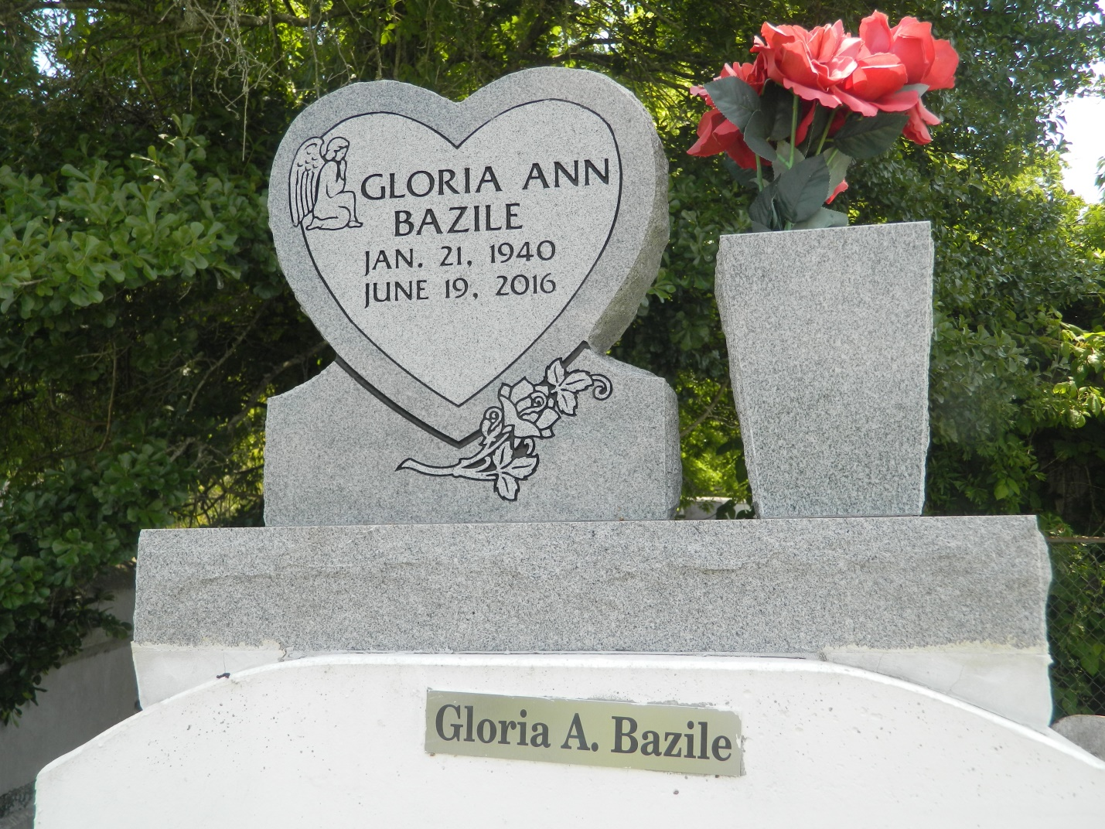

Gloria A. Bazile departed this life on Sunday, June 19, 2016; Age 76. A Devoted companion of Joseph Lee. Mother of Claudia S. Donald, Andre, Kenneth, Curtis, Jeffery, Darren, and Dawn Smith. Survived by a host of grandchildren, great grandchildren, other relatives and friends.

Funeral service will be held on Saturday, June 25, 2016 at Providence #1 B.C., 240 Pine St, LaPlace, La 70068 at 10:00 am. Rev. Willie Smith Pastor, Rev. Renard Dabney officiating. Viewing from 8:00 am until service time ONLY. Internment in Providence Rest Haven, LaPlace, LA.

Service Entrusted to Hobson Brown Funeral Home Garyville, La 70051. 985-535-2516

Times-Picayune, The (New Orleans, LA) - Wednesday, June 22, 2016

Contributed by Jane Edson