Thomas Dewayne Brown

December 27, 1968 – August 28, 2004

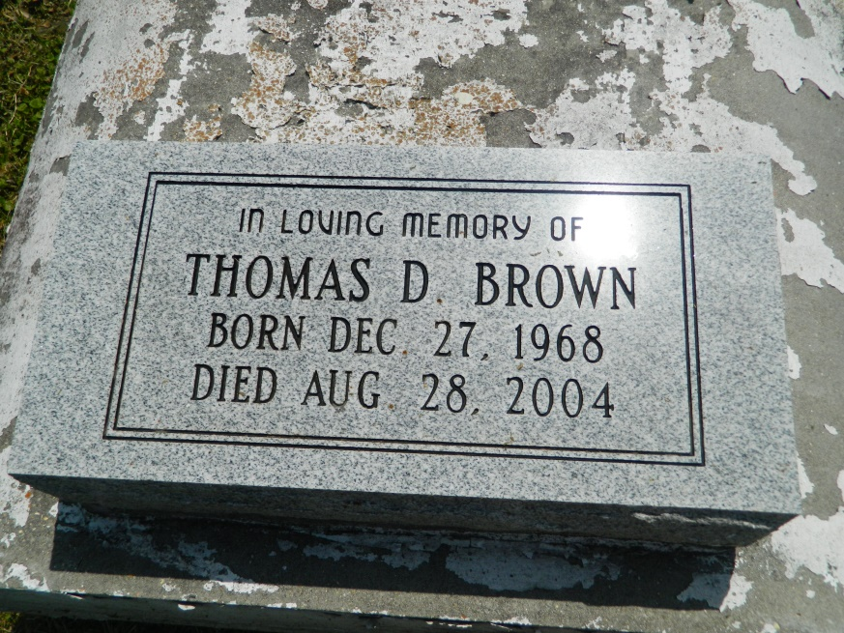

Thomas Dewayne Brown departed this earthly life and entered into Eternal Rest on Saturday August 28, 2004 at Vitas Innovative of Miami, Florida. Beloved son/stepson of Margaret/Alvin Watson of Laplace, La. Loving husband of Shauntel Monique Brown. Father of Dwanye Dominick, Thomas Dwanye, Jammorrio, Jerome, Warnell, Thomas Dwanye Jr., Thomonica Dominique, and Shunte Shakira. Brother of Robert Wilson III, Tonia Askins, Earnest, Jeanine and Trunean Brown. Grandson of the late Mable and Charlie Cade Sr. Also survived by nieces, nephews, other relatives and friends.  
  
Relatives and friends of the family also pastors, officers and members of the Spirit of Liberty Full Gospel Church of Laplace, LA., New Covenant Evangelistic Church of Harvey, LA and all neighboring churches are invited to attend the funeral services at the Spirit of Liberty Full Gospel Church 603 Main St. Laplace, LA on Saturday September 4, 2004 at 11:00 AM. Apostle Earl Gerard III officiating. Interment in Providence Rest Haven Cemetery of Laplace, LA. Visitation will be at the church from 10:00 AM until service time  
  
Bardell's Mortuary of Mt. Airy, LA in charge. Information: 985-535-6837

Times-Picayune, The (New Orleans, LA) - Friday, September 3, 2004

Contributed by Jane Edson