Fairetta (James) Holmes Cola

August 9, 1951 – October 7, 2007

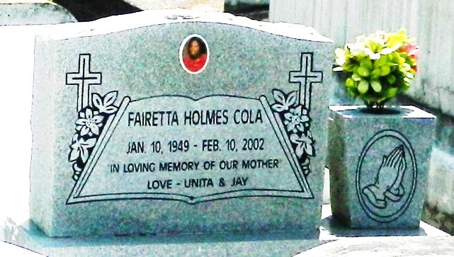

Fairetta Holmes Cola, a retired operator at Constar International Inc., died Feb. 10 of complications from a stroke at River Parishes Hospital. She was 53. Mrs. Cola was born in Waco, Texas, and lived in LaPlace for 51 years. She graduated from Fifth Ward High School in Reserve and attended Katie's Beauty School in New Orleans. Survivors include her husband, Erroll Cola Sr. of Convent; a son, Erroll Cola Jr.; a daughter, Unita Cola Marbley of St. Rose; her father, Peter James Jr.; three brothers, Peter James III and Carl James Sr. and Melvin James of New Orleans; and three sisters, Gloria Knight and Linda Wilson and Beverly Washington of Houston.

A funeral will be held Friday at 11 a.m. at Milesville Memorial Church of God in Christ, 129 Apple St., LaPlace. Visitation will begin at 10 a.m. Burial will be in Providence Rest Haven Cemetery in LaPlace.

Hobson Brown Funeral Home is in charge of arrangements.

Times-Picayune, The (New Orleans, LA) - Thursday, February 14, 2002

Contributed by Jane Edson