Pearl (Hampton) Dawson

October 28, 1945 – June 5, 2003

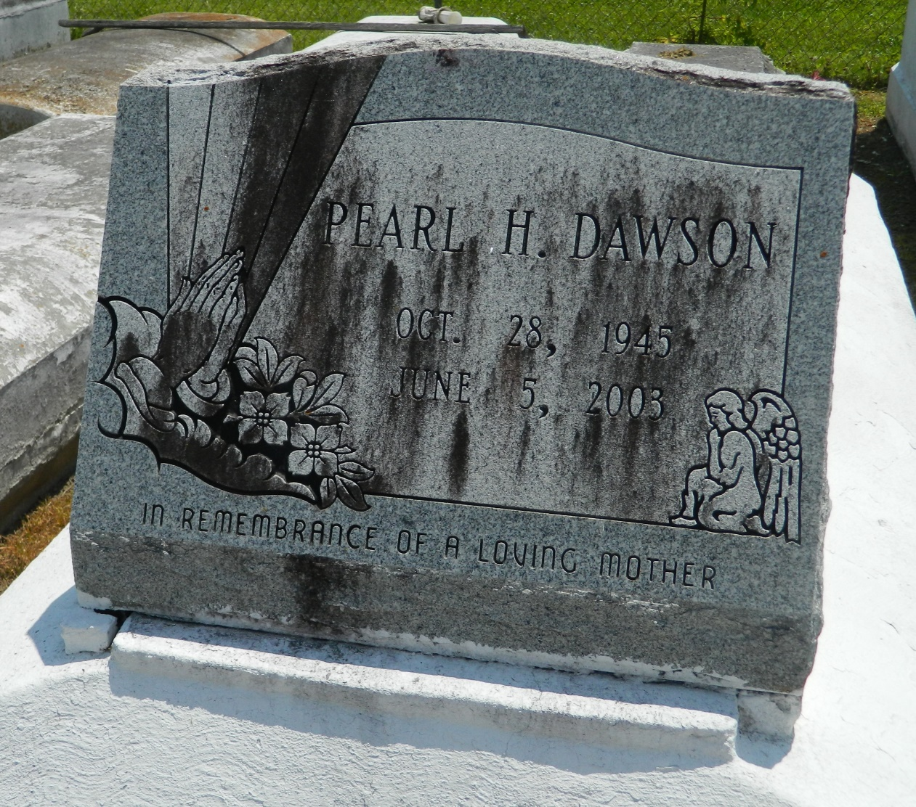

Pearl "Betty" H. Dawson, a homemaker, died June 5 of undetermined causes at Kenner Regional Medical Center. She was 57. Mrs. Dawson was born in Woodville, Miss., and lived in LaPlace for 32 years. Survivors include two daughters, Ruby H. Holmes of New Orleans and Carol J. Dawson; two sons, Herman L. Dawson Jr. and Rodney L. Dawson; six sisters, Celeste McKenzie of Avondale, Augusta Carter of New Orleans, Susie Hampton, Claretha Favors, Irma H. Womack of Dallas and Ethelene Hampton of Reserve; three brothers, John L. Hampton Sr. and Henry and Willie L. Hampton, all of New Orleans; and a grandson. A funeral will be held Saturday at 11 a.m. at Providence Baptist Church No. 1, 240 Pine St., LaPlace. Visitation will be at 9 a.m. Burial will be in Providence Rest Haven Cemetery in LaPlace. Baloney Funeral Home is in charge of arrangements.

Times-Picayune, The (New Orleans, LA) - Friday, June 13, 2003

Contributed by Jane Edson