Augustine (Millet) Dennis

August 17, 1928 – July 28, 2008

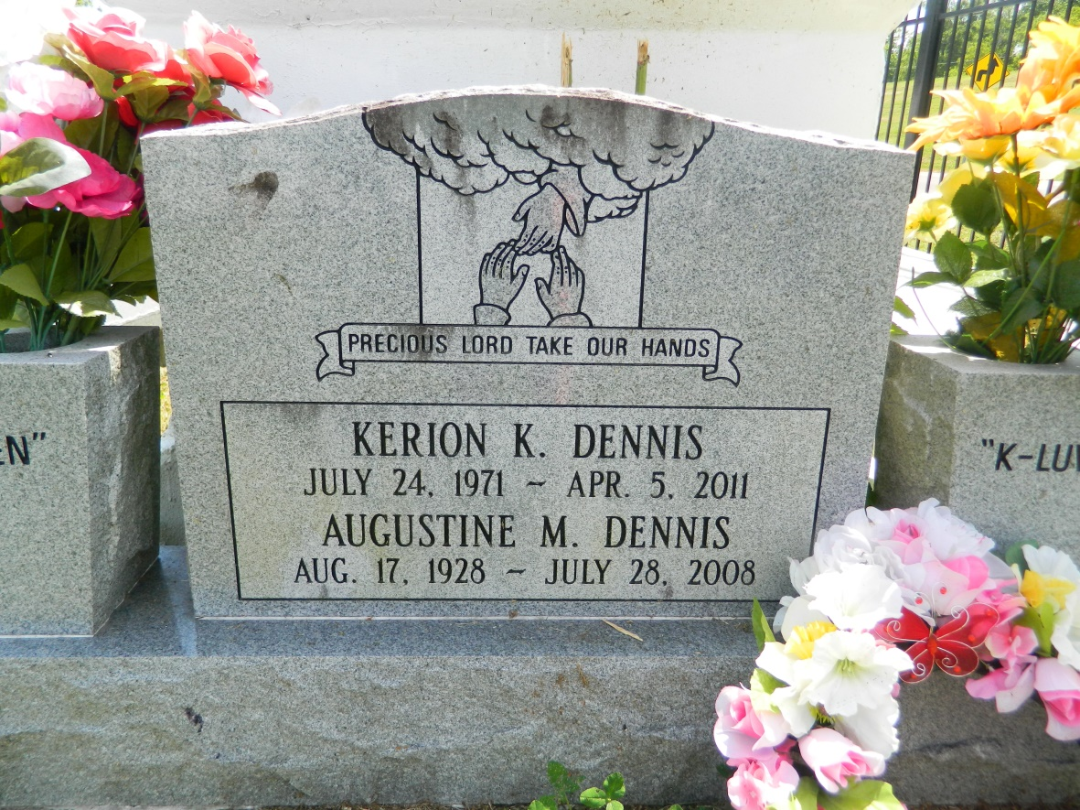

Augustine "Teen" Millet Dennis on Monday, July 28, 2008 at her son's home in Reserve, LA. Daughter of the late Orell and Adam Millet. Wife of the late Irvin Dennis. Mother of Barbara Dennis, Diane Jackson, Adaline Turner, Gary Millet and the late Marion Dennis. Sister of Claude "Pepper" Millet, the late Ceola Payne, Dorothy Jones, Leanna Batiste, Julia, Whitney, Sr., Wilbert and Joseph Millet. Also survived by 13 grandchildren, 23 great grandchildren, 2 great great grandchildren, and a host of nieces, nephews, other relatives and friends. Age 80 years. A native and resident of LaPlace, LA.  
  
Relatives and friends of the family, also pastors, officers and members of Providence Baptist Church and all neighboring churches are invited to attend the funeral service at Providence Baptist Church, 240 Pine Street, LaPlace, LA, on Saturday, August 2, 2008 at 10:00 AM. Rev Willie Smith, Pastor, Officiating. Interment Providence Cemetery, LaPlace, LA. Visitation at the above named from 9:00 AM until service time.  
  
SERVICED BY ROBOTTOM

Times-Picayune, The (New Orleans, LA) - Friday, August 1, 2008

Contributed by Jane Edson