Ethel (Frank) Forest

October 5, 1935 – August 2, 2022

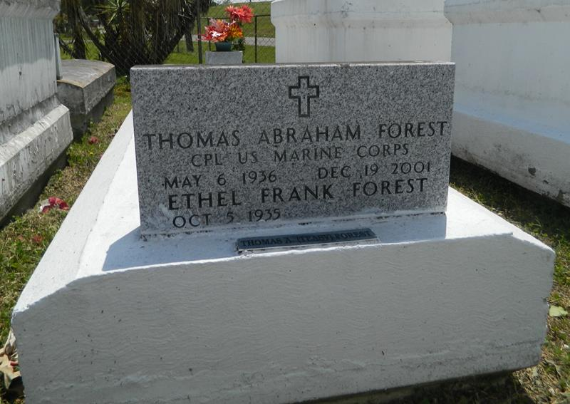

Ethel F. Forest passed away on Tuesday, August 2, 2022, at 11:00 a.m., surrounded by her family. She was 86 years old. Beloved wife of the late Thomas A. Forest. Cherished mother of Carl (Deborah) Frank, Carolyn F. (Thomas) Jones, Kenneth (Tamela) Forest, Darrell (Stephanie) Forest, Tommy (Mia) Forest, Eric (Delean) Forest and Peter G. Forest. Grandmother of 22 and great grandmother of 37. She was a retiree of Laplace cleaners. Ethel is survived by a host of other relatives and friends.

Pastor, officers and members of Mount Calvary B.C. and all neighboring churches, compassionate nurses and doctors of East Jefferson General Hospital are invited to attend the home going service at the above named church, 127 W 3rd St., Laplace, LA on Saturday, August 13, 2022, at 11:00 am. Reverend Freddie Howard, Pastor, Officiating. Visitation on Saturday, August 13, 2022, at the Church from 9 am until service time. Interment in Providence Rest Haven Laplace, LA. \*\*Mask and Social Distancing are Recommended\*\* Professional Service entrusted to Hobson Brown Funeral Home, 134 Daisy St. Garyville, LA., 985-535-2516.

Published by The Times-Picayune from Aug. 11 to Aug. 13, 2022.