Gladys (Young) Gray

January 29, 1915 – October 22, 2005

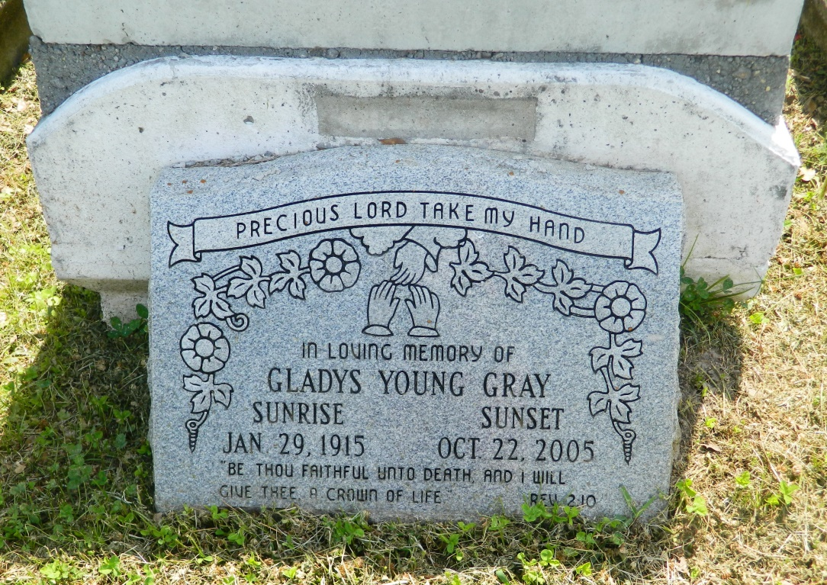

Gladys Y. Gray departed this life on Saturday, October 22, 2005 at St. James Parish Hospital Lutcher, LA. Daughter of the late Primilla and Joseph Young. Beloved wife of Nelson Gray. Mother of Dorothy W. Williams Joyce S. Randall of LaPlace and Linda G. Joseph of Kenner, LA. Also survived by 19 grandchildren, 32 great-grandchildren, 6 great great grandchildren; 1 son-in-law, Larry Joseph; 3 godchildren; a host of nieces, nephew, other family and friends. A native and resident of LaPlace, LA. Age 90 years.  
  
Members of Providence B.C., Rising Star B.C., Williams Blvd B.C. and all neighboring churches, employees and staff of Riverland Health Care Center, St. James Parish Hospital, are invited to attend the Funeral Service on Wednesday, October 26, 2005 at 11:00 a.m. from Providence B.C.# 1228 Pine St., LaPlace, LA. Rev Willie Smith, Pastor officiating, visitation Wednesday October 26, 2005 from 9:00 until service time at the church. Interment in Providence Rest Haven Cemetery, LaPlace, LA.  
  
Service entrusted to HOBSON BROWN FUNERAL HOME, Garyville, LA

Times-Picayune, The (New Orleans, LA) - Tuesday, October 25, 2005

Contributed by Jane Edson