Rose Marie (Watson) Griffin

October 26, 1943 – March 1, 2007

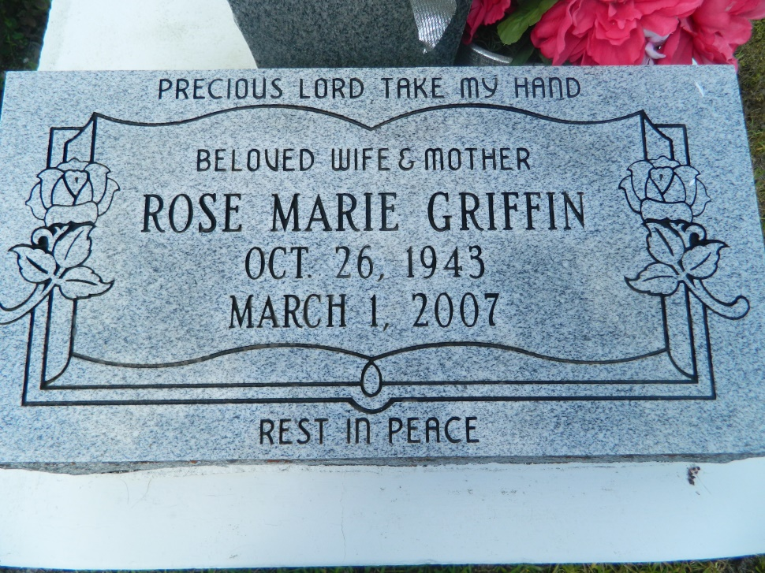

Rose Marie Watson Griffin, a native of Lutcher, LA and a resident of LaPlace, LA, she died at 12:45 p.m., Thursday, March 1, 2007 at Select Specialty Hospital, Metairie, LA. She was 63. Survived by her husband, Lionel Griffin of LaPlace, LA; three daughters and their spouses: Caprina Grffin and companion, Furnell Stevens, April Harris and husband, Harlon and Shiria Wallace and husband, Shawn; two sons and their spouses: Javan Griffin and wife, Amanda and Aaron Griffin and wife, Terrez; a sister, Welma Sue Weber; two brothers: Lawrence and Stanley Watson; adopted daughter, Royale Morgan; four sisters-in-law: Darlene and Yvette Watson, Kim Carter and Betty Griffin; three brothers-in-law, Walter Carter, Gregory Griffin and George Weber; eight grandchildren; aunts, uncles, nieces, nephews, cousins, other relatives and friends. Preceded in death by her parents, Handy Clifton Watson and Pearl Harris Watson; her maternal grandmother, Delhia Bartley; a brother, Glynn Watson; a sister, Ruth Watson; two sons: Areginald and Corey Griffin; her mother-in-law, Theresa Manuel; and father-in-law, Isaac Griffin.  
  
Visiting at Mt. Calvary B.C., 127 West 3rd Street, LaPlace, LA, Saturday, March 10, 2007 from 9:30 a.m. until Religious Services at 11:00 a.m. Conducted by the Rev. Dr. Freddie Howard. Burial in Providence Cemetery, LaPlace, La.  
  
BRAZIER-WATSON FUNERAL HOME in charge of arrangements.

Times-Picayune, The (New Orleans, LA) - Friday, March 9, 2007

Contributed by Jane Edson