Laura (Baker) Howard

February 7, 1911 – December 26, 2003

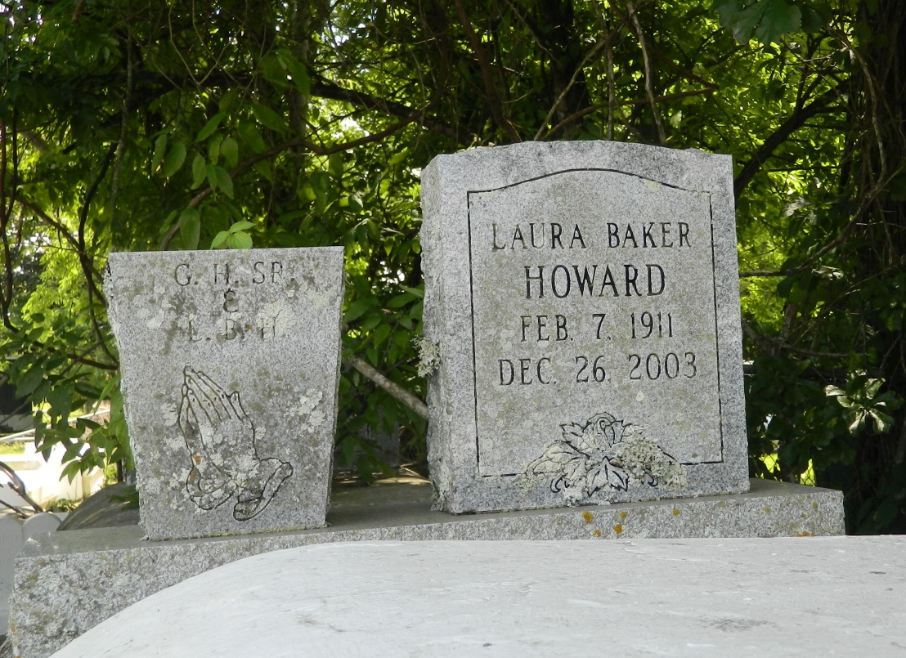

LAPLACE - Laura Baker Howard, 92, a native of Lucy and resident of Reserve, died Dec. 26. She was the wife of the late Brother Gustave "Jack" Howard, and mother of Gladys Joseph, Mildred Dennis, LaBorah Francois, Rose Mary Walton, Isabella Gerard, Minister Deloris Millet, Elder Joyce Brown, Prophetess Laura Vampran, Jack, Easter and Dr. Rev. Freddie Howard, and stepmother of Barbara Breaux, and the late Gustave Howard Jr.  
  
She was also the daughter of the late Louis and Elizabeth Baker.  
  
She is also survived by 78 grandchildren, 156 great-grandchildren and 78 great-great-grandchildren.  
  
Services are today at 11 a.m. at Mt. Calvary Baptist Church, LaPlace, with interment at Providence Rest Haven Cemetery, LaPlace. Visitation starts at 10 a.m.

L'Observateur (La Place, LA) - Friday, January 2, 2004

Contributed by Jane Edson