Ardricher Johnson

September 27, 1924 – April 29, 2008

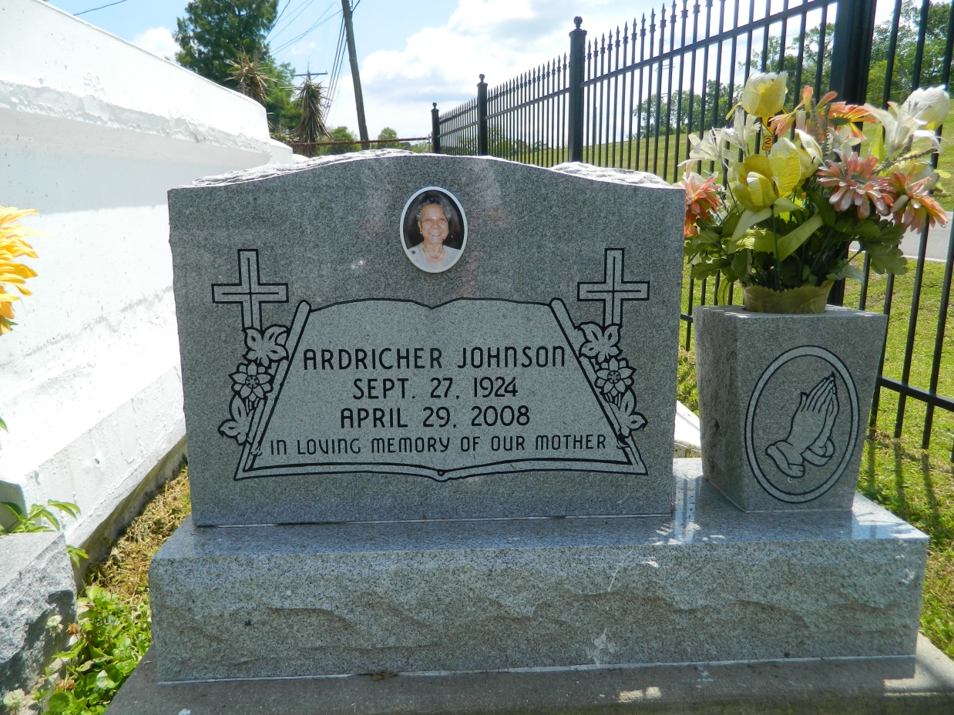

Mrs. Ardricher Johnson, age 83, passed away on Tuesday, April 29, 2008 at St. James Parish Hospital in Lutcher, LA.  
 Relatives, friends of the family are invited attend her Homegoing Celebration on Saturday, May 3, 2008, 11:00AM at Providence Baptist Church #1, 238 Pine St., LaPlace, LA.

Visitation will be held from 9:00AM until the hour of service. Interment Resthaven Providence Cemetery.  
 Friends are also invited to the visitation this evening, Friday, May 2, 2008, 7:00-9:00PM at the Betty Ann Sanders Memorial Chapel of Professional Funeral Services, 605 Main St., LaPlace, LA.  
 She leaves to cherish her most precious memories 6 children: Andrea Scales, Percy Jr. and Bendera Johnson, Viola Brown, Grrdenia Narcissa, Ervin Brooks, Sr.  
 Professional Funeral Services, Inc., 605 Main Street, LaPlace, LA 70068; (985) 652-1730

Times-Picayune, The (New Orleans, LA) - Friday, May 2, 2008

Contributed by Jane Edson