Leola (Batiste) Johnson

August 8, 1922 – August 13, 2011

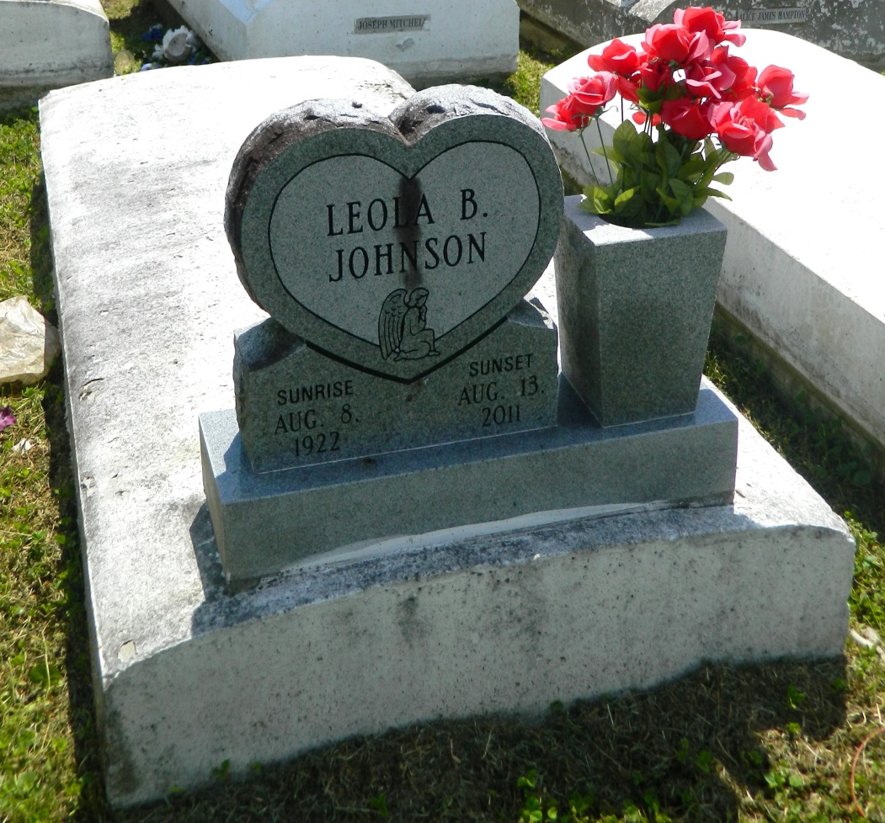

Sister Leola "Nanan" Johnson was called home by the angels of the Lord on Saturday, August 13, 2011 at 6:15 p.m. at the home of her daughter Audrey Mason. She was 89 years old. Sister Leola "Nanan" was the daughter of the late James Batiste Jr. and the late Viola Stewart Batiste. Leola "Nanan" was married to the late Alex Johnson Sr. From this union was three children: Audrey Mason, Herbert Johnson and the late Alex Johnson Jr. "Nanan" was the grandmother of 12 grandchildren and the great-grandmother of 21 great-grandchildren and 36 great-great grandchildren. One sister, Louise Tuircuit (Michael); three brothers: Minister Joseph Batiste, Rogers (Cewillow) Batiste, Morris Batiste; and one daughter-in-law, Deon Johnson. Sister Leola accepted Christ at the young age of 12. She was baptized by Minister T.A. Smith and was a member of Providence Baptist Church #1 where she served faithfully as a choir member alongside her mother and many others that have been called home. Sister Leola retired from Twin Oaks Nursing home many years ago. She was preceded in death by her husband Alex Johnson Sr., son Alex Johnson Jr., brothers, Junius "Sugar Babe", Ernest, Clarence, Raymond, Roy Batiste, and son-in-law, Joseph Mason, daughter-in-law, Mary Johnson, sisters-in-law, Audrey, Hilda, and Emma Batiste, and one great-grandson Herbert Elderon Johnson.  
 The public, friends, New Rescue Mission Baptist Church and surrounding churches are invited the attend the Christian service at Providence #1 Baptist church, 240 Pine Street, Laplace, LA, on Saturday, August 20, 2011, at 11:00 a.m. Pastor Willie Smith officiating. Visitation will be from 9:00 a.m. until time of service with burial in church cemetery. Arrangements by the Baloney Funeral Home LLC, 399 Earl Baloney Street, Garyville, LA, 985-535-2540.  
 Guests may sign the register at [www.baloneyfuneralhome.com](http://www.baloneyfuneralhome.com/).

Times-Picayune, The (New Orleans, LA) - Friday, August 19, 2011

Contributed by Jane Edson