Maudrey Mae Johnson

Abt. 1936 – November 6, 2019

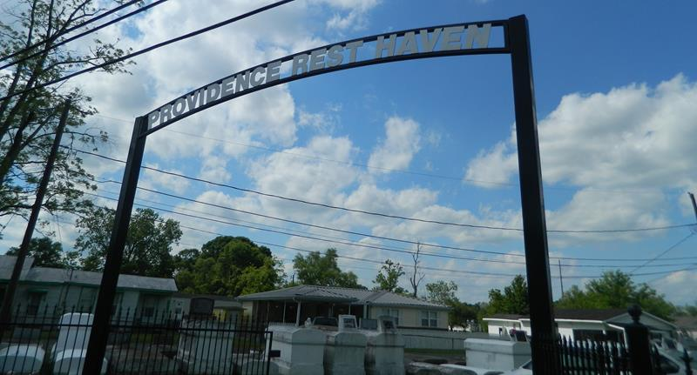

Maudrey Mae Johnson, a life-long, well-known, and respected resident of Laplace, LA, entered into eternal rest peacefully at her home on Wednesday, November 6, 2019 at the age of 83. She was a devout Christian with a profound love and passion for the Word of God. She was an active member of the Providence Baptist Church in Laplace, LA where she served as a deaconess until God called her home. She was a people-oriented, vibrant, and energetic woman who took pride in tending to the community and anyone that she encountered. She dedicated over 20 years of her life to the St. John Council on Aging where she faithfully ministered and participated in group activities and events. She was a retired cook for the St. John Parish School System. Maudrey leaves to cherish in her memories a devoted daughter, Marilyn M. Scott of Laplace; 6 siblings: Beaulah Colbert, Vivian Davis, Barbara Gibbs, John Daniel Johnson, Raymond Johnson, and Randolph Anthony; 18 grandchildren; and a host of great grandchildren, nieces, and nephews. Maudrey was preceded in death by her parents, Sidney Johnson, Sr. and Ethel; 4 brothers: Percy Johnson, Wilbert Johnson, Sr., August Johnson, and Sidney Johnson, Jr.; and 2 sons: Jerry Morris and Wendell Morris. Family and friends are invited to attend the visitation on Friday, November 15, 2019 beginning at 3:00 pm until 6:00 pm at Bardell's Mortuary, located at 3856 LA-44 in Mount Airy, LA. On Saturday, November 16, 2019 visitation will begin at 9:00 am at Providence Baptist Church in Laplace followed by funeral services at 11:00 am, officiated by Pastor Willie Smith. Burial will follow in Providence Resthaven Cemetery. Bardell's Mortuary has been entrusted with the funeral arrangements. Information: (985)535-6837

Published in The Times-Picayune on Nov. 15, 2019