Delores (Baker) Joseph

November 3, 1936 – September 3, 2006

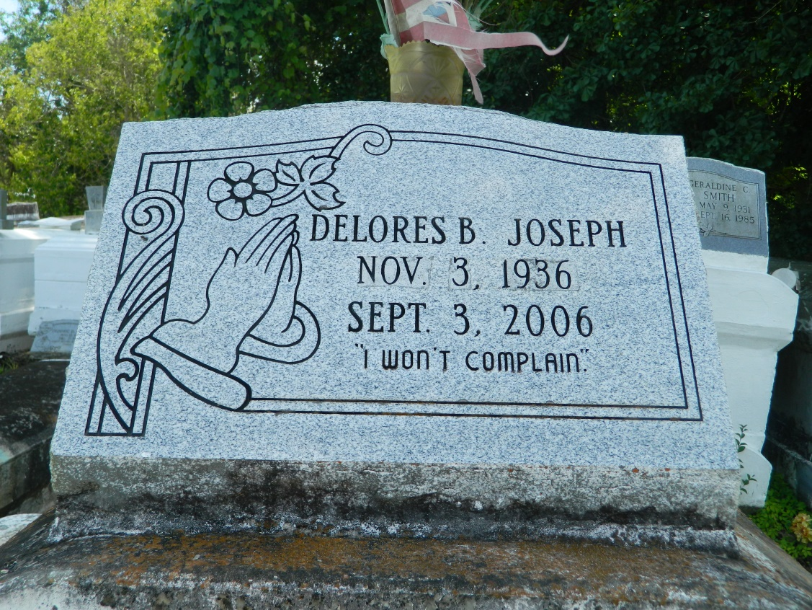

Delores "La Lou" Baker Joseph, age 69, a homemaker passed away peaceful on Sunday, September 3, 2006 in Houston, Texas. Daughter of the late Alexander Baker and Zeolia Pierre. Wife of the late Melvin Joseph, Sr. Mother of Mary Ceaser, Melvin Joseph, Jr., Robin Aubert, and Rochelle Bourgeois. Sister of Herbert and Dorothy Baker, also survived by (10) grandchildren, (6) Great Grandchildren and a host of nieces, nephews, other relatives and friends. A native and resident of LaPlace, LA.  
  
Pastor and members of Providence B.C., and all neighboring churches are invited to attend funeral service on Satruday, September 9, 2006 at 12:00 noon from the above named church, 240 Pine St., LaPlace, LA., Rev. Willie Smith, Pastor, Officiating. Interment in Church Cemetery, LaPlace, LA. Viewing at the church from 11:00 AM until service time  
  
Service entrusted to HOBSON BROWN FUNERAL HOME, Garyville, LA.

Times-Picayune, The (New Orleans, LA) - Friday, September 8, 2006

Contributed by Jane Edson