Hurain Sr. “Joe” Joseph

December 17, 1950 – June 8, 2003

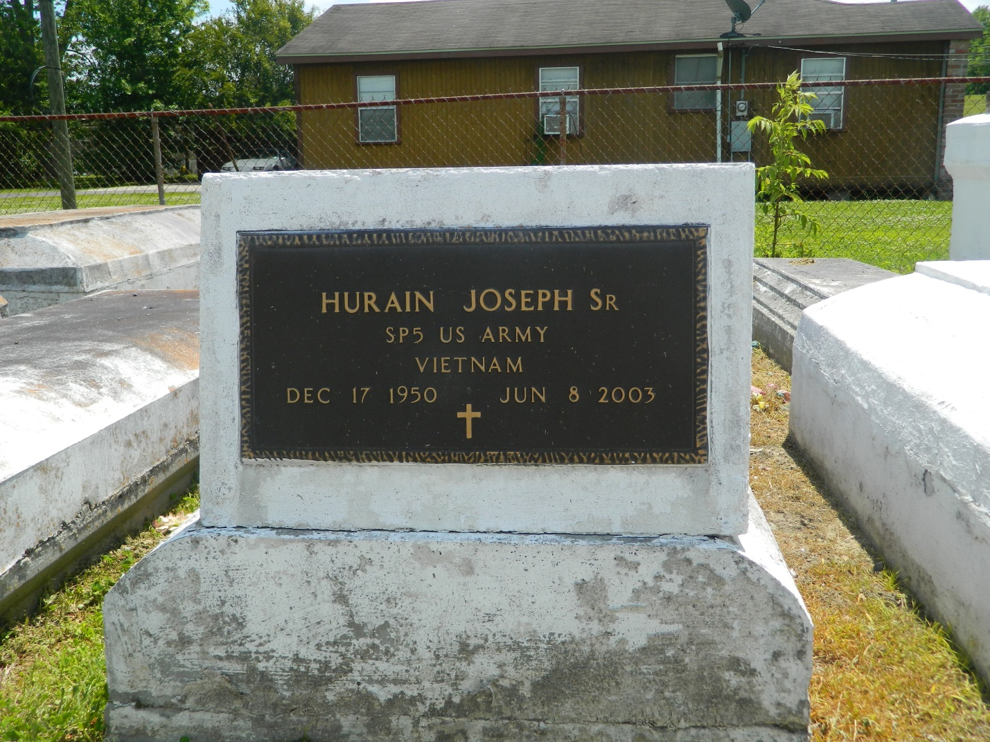

Hurrain "Joe" Joseph departed this life on Sunday, June 8, 2003 at his residence Laplace, La. Son of the late Mr. and Mrs. Henry Joseph Sr., Husband of Diane Joseph, father of I'Unekia Joseph, Byron Glapion, Sr., Jurrain and Ahriel Lennix, (2) step-children, Dioandra Parquet and Lorenzo Barnes. Brother of Veronica Scott of Garryville, Valerie Keller of Destrehan, Katie Sarah of Kenner, Henry Eric, and Reverend Reginald Joseph of Laplace, Ricky Joseph of Augusta, Georgia and Rodney M. Joseph of Mt. Airy, (1) grandchild, Byron Glapion, Jr. Also survived by a host of Brothers and Sisters-in-law, a host of aunts, uncles, nephews, nieces other relatives and friends. A native of Mt. Airy and resident of Laplace. Age 52.  
  
Relatives and friends of the family, pastor, officers, and members of Greater King Triumph Baptist Church and all neighboring Chuches, Employees of EI Dupont/Dow Elastomer Plant, Reserve, Delta Waste Systems, Harvey, Shell Chemical and Burns Security, Norco, St. Charles Parish School Board, Twin Oaks Nursing Home, Laplace, CS Metals LLC, Convent,The University of Georgia, and The Orion Oil Refinery Norco, are invited to attend the funeral services from the above named church, 2572 Lionel Washington St. Lutcher, La., on Saturday, June 14, 2003 at 11:00 a.m. Reverend Reginald Joseph Pastor Officiating, viewing will begin at 10:00a.m. until funeral time. Interment in Providence Rest Haven, Laplace,La.  
  
Services Entrusted to Hobson Brown Funeral Home

Times-Picayune, The (New Orleans, LA) - Friday, June 13, 2003

Contributed by Jane Edson