Cornelia “Connie” Lewis

July 5, 1923 – August 6, 2004

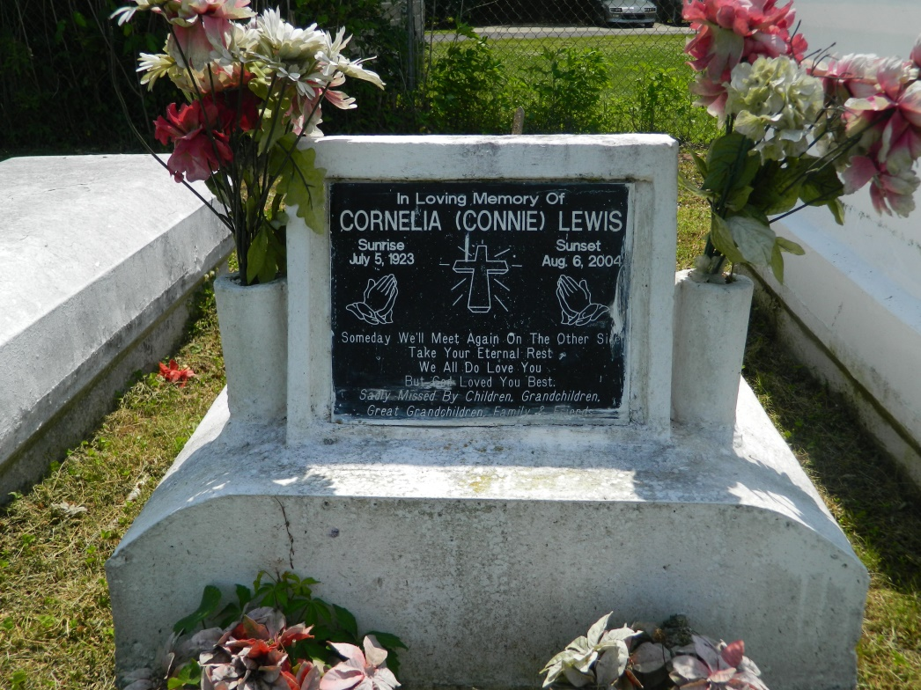

Cornelia Lewis, departed this earthly life and entered into eternal rest on Friday, August 6, 2004, at St. James Hospital, of Lutcher, LA. Wife of the late Edward Lewis, Sr. Loving mother of Doris Cooks, Melvin Lewis, of Reserve, LA, Edward Lewis, Jr., Emily Parquet, Herman Lewis, Sr., Barbara Robertson, of Laplace, LA, Earl Lewis, of California, and Albert Carter, of Florida. Also survived by Sons-in-law, Daughters-in-law, 19 Grandchildren, 41 Great-Grandchildren, Nieces, Nephews, other relatives and friends, Age 81 Years.  
  
Relatives and Friends of the Family, also Pastors, Officers and Members of Providence II Baptist Church, of Montz, LA, and all neighboring churches, are invited to attend the Funeral Services, on Saturday, August 14, 2004, at 10:00 A.M. , at Providence II Baptist Church, 152 Union Lane, Montz, LA. Rev. Donald Brown, Officiating. Interment in Providence Cemetery, Laplace, LA. Visitation will be at the church from 8:00 A.M. until service time.  
  
BARDELL'S MORTUARY of MT. AIRY, LA, in charge. Information: 985-535-6837.

Times-Picayune, The (New Orleans, LA) - Friday, August 13, 2004

Contributed by Jane Edson