Elton Millet

October 5, 1959 – October 23, 2008

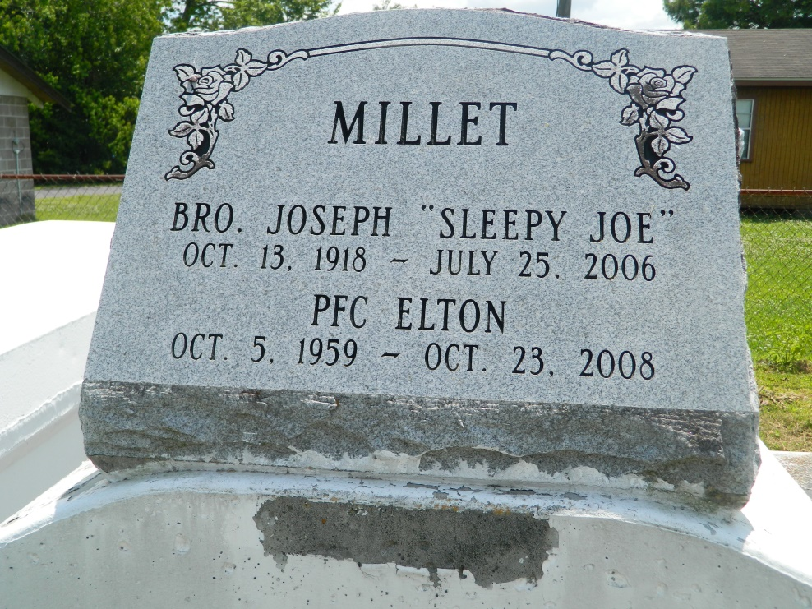

Brother Elton Millet, age 49, a United States Army Veteran, departed this life on Thursday October 23, 2008 at in Laplace, La. Son of Helen F. Millet and the late Joseph Millet. Brother of Jackie Harris, Dolores Martin, Clarence Variste, the late Audrey Ester and Rose Mary Dennis. Also survived by a host of nieces, nephews, aunts, uncles, sister-and brother-in-law, other relatives, and friends.  
  
Family and friends are invited to attend the Funeral Service on Friday, October 31, 2008 at 11:00a.m at New Wine Christian Center, 1801 W. Airline Hwy., Laplace, La. Rev. Neil Bernard, Pastor Officiating. Interment in Providence Rest Haven Cemetery Laplace, La. Visitation at the church from 9:00a.m until service time. (ONLY)  
  
Service entrusted to Hobson Brown Funeral Home, 134 Daisy St. Garyville, La., 70051   
985-535-2516

Times-Picayune, The (New Orleans, LA) - Thursday, October 30, 2008

Contributed by Jane Edson