Jamar Carvell Mitchell

Abt. 1878 – Janury 6, 2001

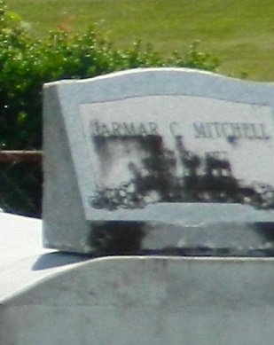

LAPLACE - Jamar Carvell Mitchell, 23, a native and resident of LaPlace, died Jan. 6. He was the son of Donald and Brenda Vinnett Mitchell and brother of Gayland and Trent Mitchell. He was also the grandson of Marjorie Vinnett and Leona Jones. Services are today at 10 a.m. at New Wine Christian Fellowship, LaPlace, with interment at Providence Resthaven Cemetery, LaPlace. Visitation starts at 9 a.m.

L'Observateur, LaPlace, LA; January 13, 2001

Submitted for the LA GenWeb Archives by: Donald W. Johnson