Joseph Mitchell Jr.
November 27, 1925 - August 14, 2002

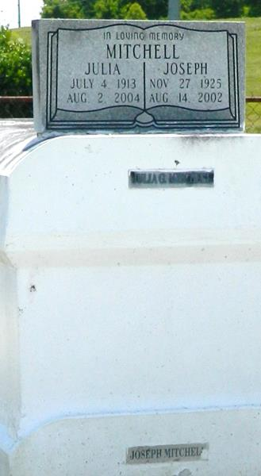

MITCHELL LAPLACE – Joseph Mitchell Jr., 76, a native and resident of LaPlace, died Aug. 14. He was the husband of Julia Green Mitchell and stepfather of Bessie Mae Brown, Marion Perrilloux, Gloria Mitchell and Raymond, Harold and Clarence Breaux. He was the brother of Wilfred Mitchell Sr. He is also survived by many grandchildren and great-grandchildren. He was a veteran of World War II and a retired porter for Avis Rent-a-Car. Services were Aug. 22 at Mt. Calvary Baptist Church, LaPlace, with interment at Providence Memorial Resthaven Cemetery.

L’Observateur, LaPlace, Louisiana
Tuesday, August 27, 2002

