Lamont D. Mitchell, Sr.

May 11, 1976 – August 4, 2003

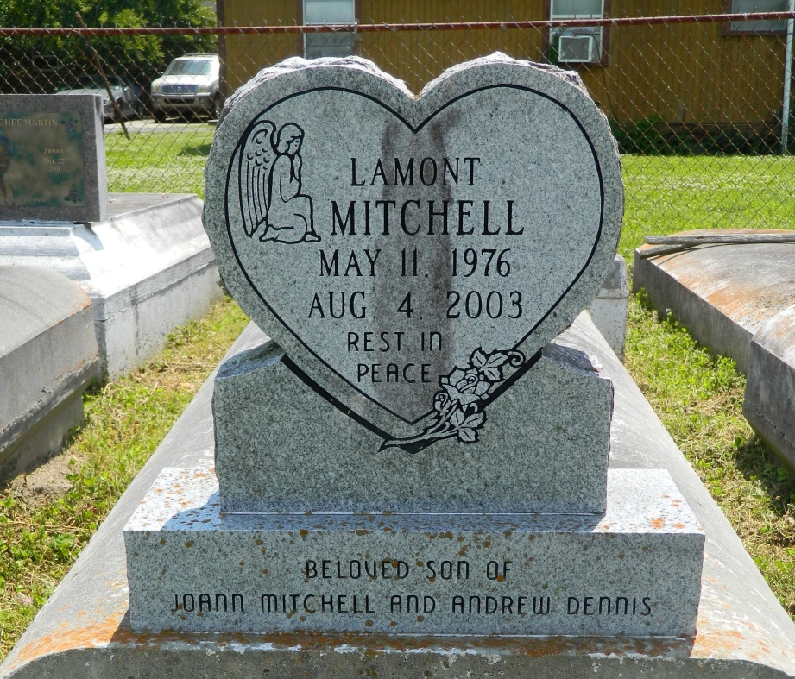

Master Sergeant Lamont D Mitchell, 27

LaMont D. Mitchell Sr., a laborer for Labor Ready Job Services, died Aug. 4 of a gunshot wound in New Orleans. He was 27. Mr. Mitchell was a lifelong resident of New Orleans. Survivors include his wife, Sabrina Heim; three sons, LaMont Mitchell Jr., Jabon Mitchell and DeVonte Gardner of Garyville; a daughter, Kaiya Mitchell; a stepson, Darryl Jones; his parents, Andrew Dennis Sr. and Joann Mitchell; his stepfather, Darryl Jones; two brothers, Terence Mitchell and Andrew Dennis Jr. of Reserve; a sister, Jazmine Mitchell; his grandparents, Lorraine Mitchell of Luling, Leo Mitchell of LaPlace and James and Mildred Dennis of Reserve; his great-grandparents, Angelina Hawkins of St. Rose and Laura Howard of LaPlace; and a companion, Keiona White. A funeral will be held Wednesday at 11 a.m. at Mount Calvary Baptist Church, 127 W. Third St. in LaPlace. Visitation will begin at 10 a.m. Burial will be in Providence Rest Haven Cemetery. Hobson Brown Funeral Home is in charge of the arrangements.

Times-Picayune, The (New Orleans, LA) - Tuesday, August 12, 2003

Contributed by Jane Edson