Ronnie Mitchell

April 9, 1946 – March 15, 2001

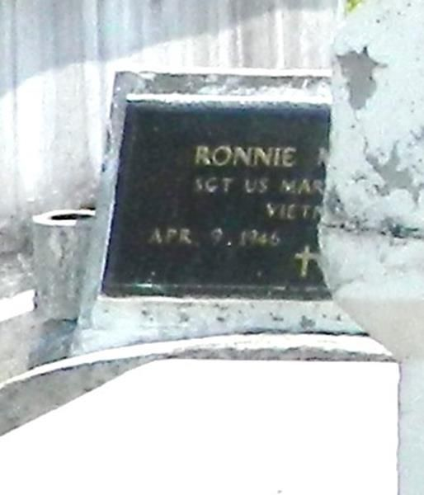

LAPLACE - Ronnie Mitchell, 54, a native of LaPlace and resident of Reserve, died March 15. He was the son of Gladys Mitchell and brother of Hilton Mitchell Jr., Donald Mitchell, and Glythina"Gayle" Batiste. Services were March 22 at Providence Baptist Church No. 1 in LaPlace, with interment at Providence Cemetary, LaPlace.

L'Observateur, LaPlace, Louisiana; March 24, 2001

Submitted for the LA GenWeb Archives by: Donald W. Johnson