Theresa G. Mitchell

April 14, 1915 – June 22, 1004

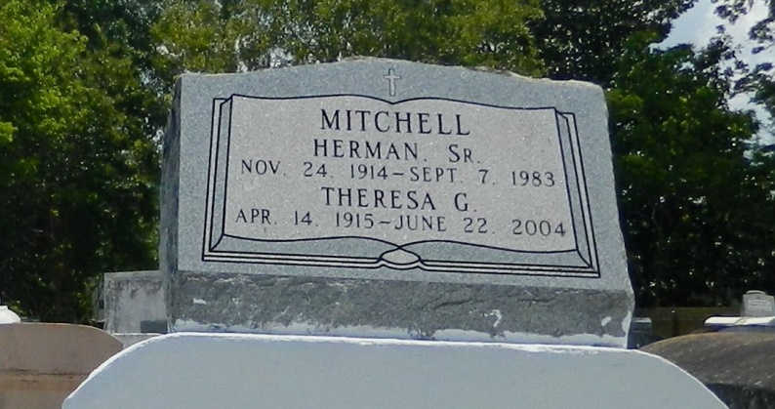

Theresa "Mommie" Mitchell, a homemaker, died Tuesday of cardiomyopathy at Twin Oaks Nursing Home in LaPlace. She was 89. Mrs. Mitchell was a lifelong resident of LaPlace. Survivors include four sons, Calvin Sr., Herman Jr., Wilbert and Whitney Mitchell; four daughters, Velma Harris, Betty McClendon, Diana Stewart and JoAnn Bailey; a sister, Julia Mitchell; 18 grandchildren; and 31 great-grandchildren. A funeral will be held Monday at 11 a.m. at Providence Baptist Church in LaPlace. Visitation will begin at 9 a.m. Burial will be in Providence Rest Haven in LaPlace. Hobson Brown Funeral Home is in charge of the arrangements.

Times-Picayune, The (New Orleans, LA) - Saturday, June 26, 2004

Contributed by Jane Edson