Ethel Mae Morris

October 21, 1930 – August 7, 2001

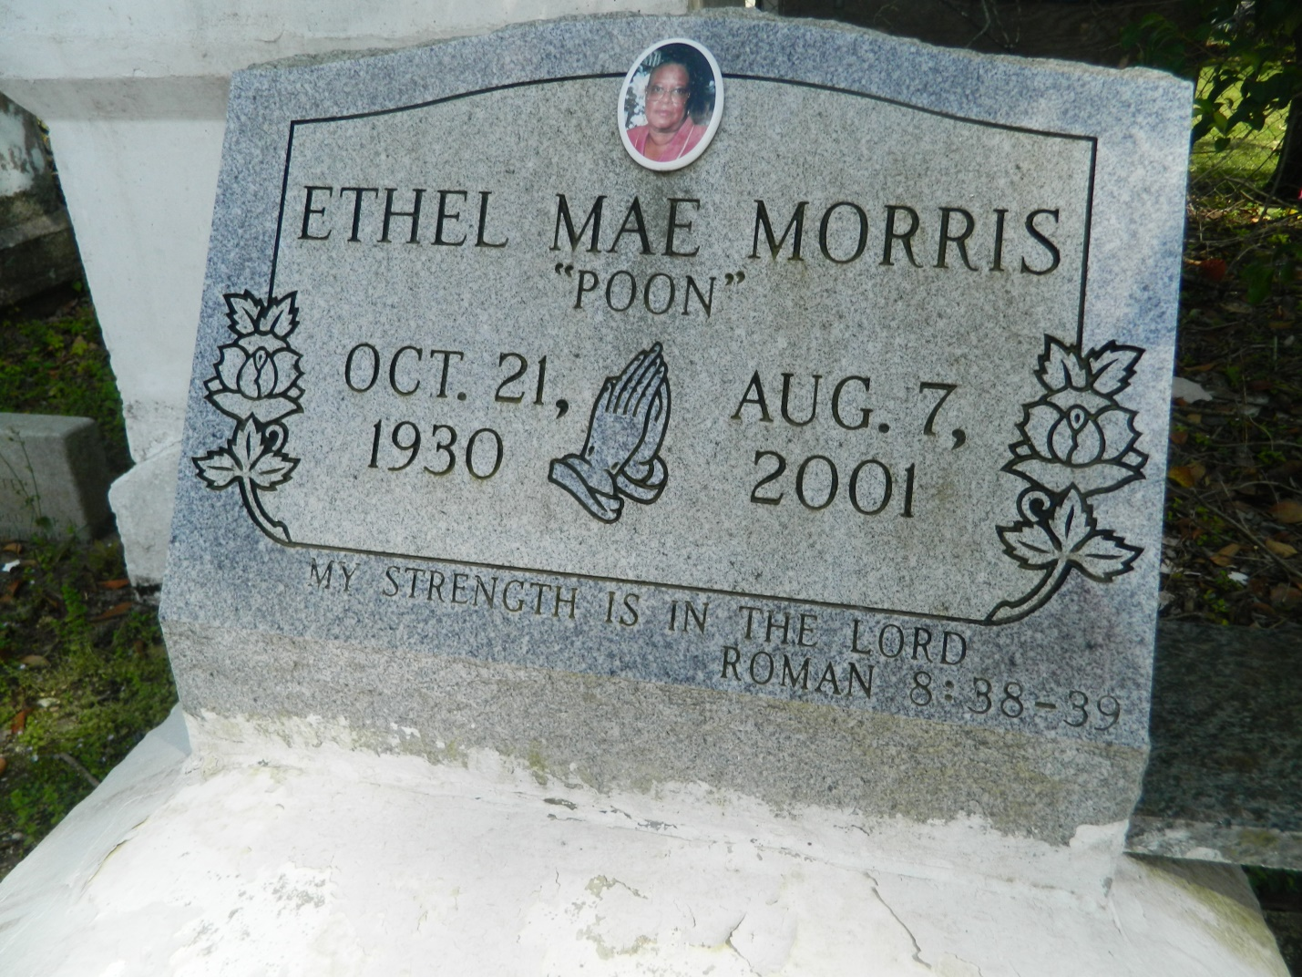

LAPLACE - Ethel Mae "Poon" Morris, 70, a resident of LaPlace, died Aug. 7. She was the mother of Rodney Evans Sr., JoAnn Morris Alexander and Raydell Morris Sr., and the late Kevin Gray. She was the daughter of the late Annie Williams and Leo Morris and the sister of Wilbert Morris, Junius Breaux, Martha Parquet and Audrey Mae Johnson, and the late John H. Lee Jr. She is survived by six grandchildren and six great-grandchildren. Services were Aug. 9 at Providence Baptist Church No. 1, LaPlace, with interment at Providence Resthaven Cemetery, LaPlace.

L'Observateur, LaPlace, LA; August 11, 2001

Submitted for the LA GenWeb Archives by: Donald W. Johnson