Nathan J. Paxton, Sr.

December 15, 1942 – January 19, 2003

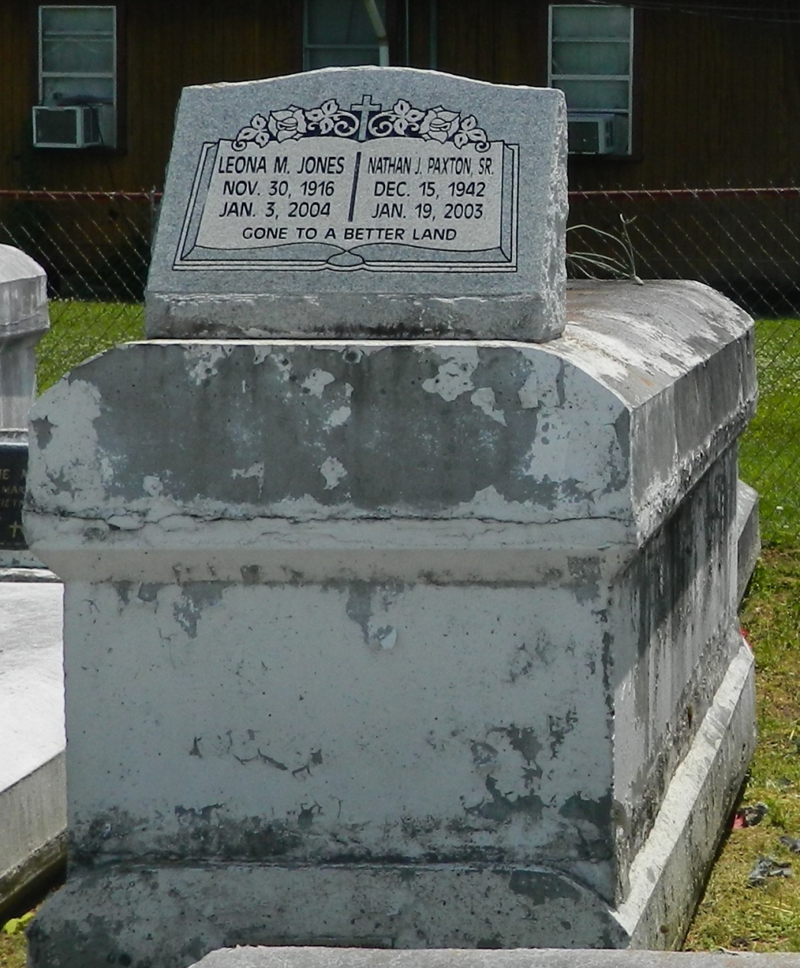

Nathan "Joe Nathan" Paxton Sr., a musician, died Jan. 19 of heart failure at Earl K. Long Hospital in Baton Rouge. He was 62. Mr. Paxton was born in LaPlace and lived in Jackson. Survivors include his son, Nathan J. Paxton Jr.; his mother, Leona M. Jones; two brothers, Edgar B. Jones of Crockett, Calif., and Donald J. Mitchell of LaPlace; two sisters, Ethel L. Paxton and Marilyn G. Francois, both of LaPlace; and three grandchildren. A funeral will be held Saturday at 11 a.m. at Milesville Memorial Church of God in Christ, 129 Apple St., LaPlace. Visitation will be today from 5 to 7 p.m. at Hobson Brown Funeral Home, 134 Daisy Street in Garyville. Burial will be in Providence Rest Haven Cemetery in LaPlace.

Times-Picayune, The (New Orleans, LA) - Friday, January 24, 2003

Contributed by Jane Edson