Jerimah Ivan Randle

May 23, 1941 – January 24, 2009

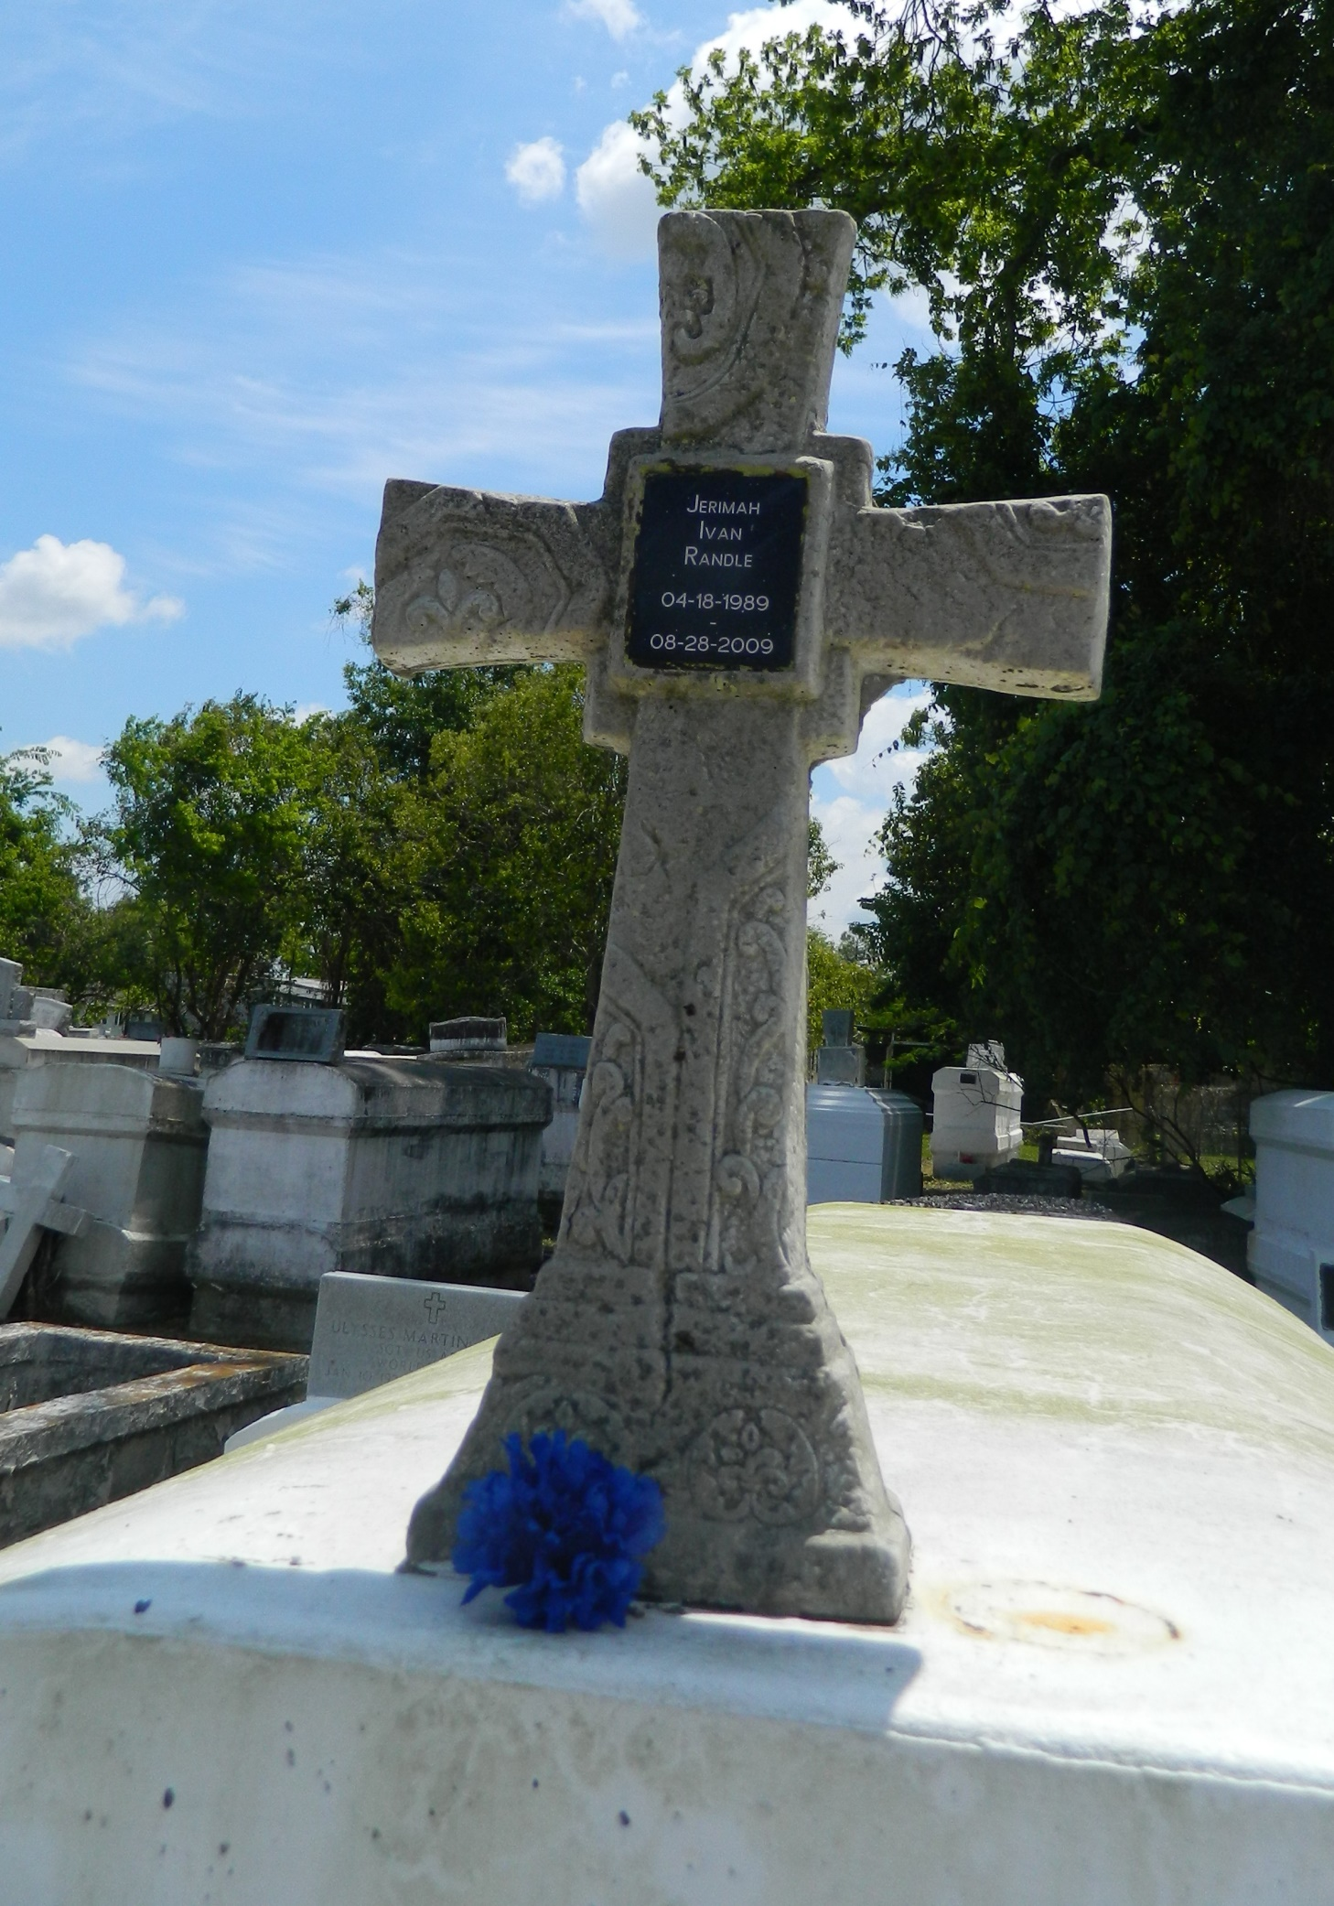

Jeremiah (sic) Randle, age 20, departed this life on Friday, Aug. 28, 2009, in LaPlace.  
  
Son of Loretta Warren and Ferdinand Perilloux and Harold Warren Sr. Also survived by five brothers, three sisters, grandparents and a host of aunts, uncles, nieces, nephews, sisters- and brothers-in-law, other relatives and friends. A native and resident of LaPlace.  
  
A Funeral Service was held on Saturday, Sept. 5, 2009, at 11 a.m. at the Greater Morning Star Baptist Church, 1003 Balsam St., LaPlace. Rev. Bryant Warren, Sr., Pastor officiated. Interment in Providence Rest Haven Cemetery, LaPlace. Visitation was held at the church prior to services. Service Entrusted to Hobson Brown Funeral Home Garyville, (985) 535-2516

L'Observateur (La Place, LA) - Wednesday, September 9, 2009

Contributed by Jane Edson