Barbara Jean (Lewis) Robertson

July 6, 1953 – June 16, 2022

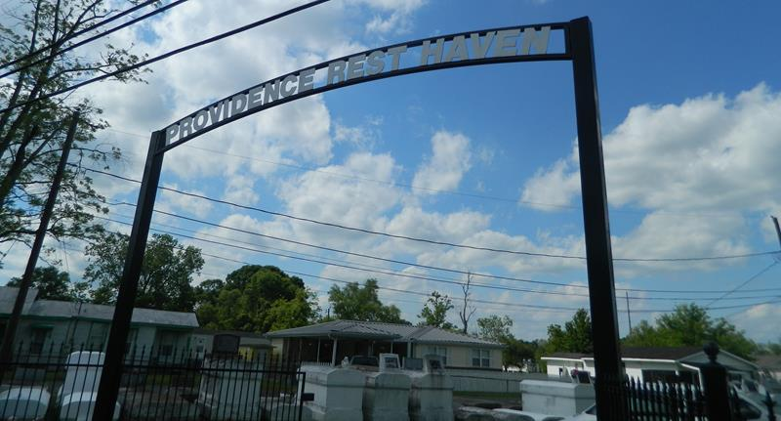

Barbara Jean Lewis Robertson transitioned from this earthly life on June 16, 2022 at Ochsner Hospital in New Orleans at 8:05 p.m. She was born on July 6, 1953 to the parentage of the late Cornelia “Connie” Lewis and Freddie “Miyee” Young, Sr. in New Orleans, Louisiana. She was the loving wife of Marty Robertson for 41 years.  
 She attended the public schools in St. John the Baptist Parish, Reserve, Louisiana. She was also employed in the St. John Parish Schools as a custodian for many years. She accepted Christ and was baptized at Mount Calvary Baptist Church in Laplace, Louisiana by the late Rev. Haskel Williams. She joined the Pilgrim Baptist Church of Reserve, Louisiana under the leadership of Rev. Dr. Forell Bering, Sr. where she proudly served on the Usher Board. She was passionate about her baking and would occasionally bake a cake from scratch for a church event.  
 Cherishing her memories are her husband, Marty Robertson; children, Euradell Fobb, Lynell Fobb, Rev. Lenord Fobb, Sr. (Travona), and Aaron Robertson (Chelsea); 7 sisters and 5 brothers; grandchildren, Janaya Lewis (Oshea), Jerinay Gray, Trenord Fobb, Trennon Fobb, Aaron Robertson, Jr., Dereion Robertson, Kayden Robertson, and Treniya Fobb; a great-grandchild, Oshea Lewis, Jr.; and a host of nieces, nephews, cousins, other relatives and friends.  
 She was preceded in death by her parents, Cornelia Lewis and Freddie Young, Sr.; sisters and brothers, Earl Lewis, Melvin Lewis, Herman Lewis, Sr., and Kevin “KB” Young; granddaughter, Trenaya Kaylen Alexis Fobb, and a host of aunts and uncles.  
 Funeral Services will be held on Saturday, June 25, 2022 at New Pilgrim Baptist Church at 107 Pilgrim Dr., Reserve, LA. The viewing will be from 10:00 am until 12:00 noon. Services will begin at 12:00 noon. Interment will follow at Providence Cemetery, 170 West Second St., Laplace, LA. Covid-19 guidelines still apply for mask wearing. Final care and professional services entrusted to Treasures of Life Funeral Services, 315 E. Airline Hwy. Gramercy, LA 70052.

Treasures of Life Funeral Services, Gramercy, Louisiana; August 15, 2022