Aslena A. Sanders

September 8, 1908 – December 6, 2008

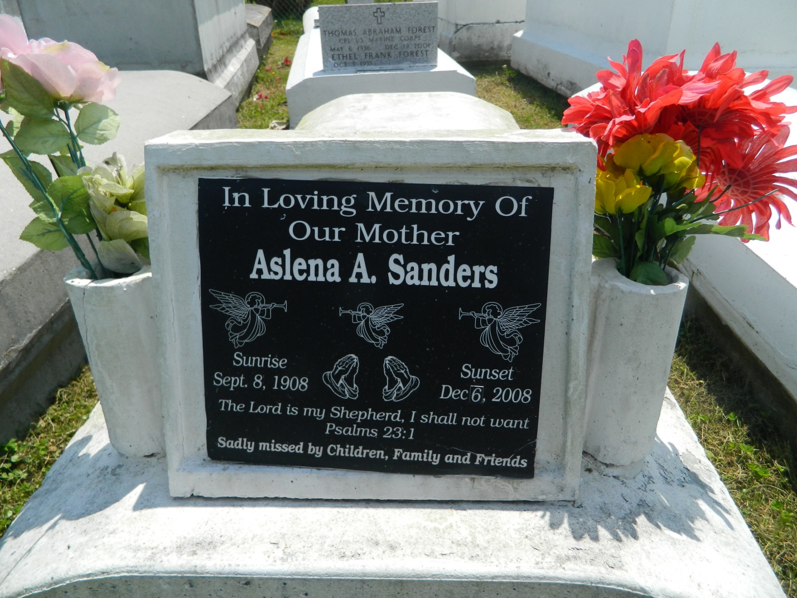

Ecc: 3:1 says, "There's a time to be born" and in 1908 Aslena was born, and "a time to die" so on Saturday, December 6, 2008 she answered the voice of her Savior at the young age of 100 years old. Beloved of wife of the late Willie Sanders, Sr. Mother of eight beautiful children. Also survived by 51 grandchildren, 112 great-grandchildren, 47 great-great-grandchildren, daughters- and sons-in-law, also a host of nieces, nephews, other relatives, and friends. A native and resident of Reserve, La. for many years. She was preceded in death by 2 sons: William Woddsy and Herbert Sanders.  
  
Pastors Officers and members of Providence B.C. and all neighboring churches are invited to attend the Homegoing Service on Saturday, December 13, 2008 at 10:00a.m. at the above name church, 240 Pine St., Laplace, La. Pastor Willie Smith Officiating. Interment in Church Cemetery, Laplace, La.  
  
Service entrusted to Hobson Brown Ffuneral Home, Garyville, La., (958) 535-2516

Times-Picayune, The (New Orleans, LA) - Friday, December 12, 2008

Contributed by Jane Edson