Allen Joseph Schnyder Sr.

February 20, 1938 – April 19, 2004

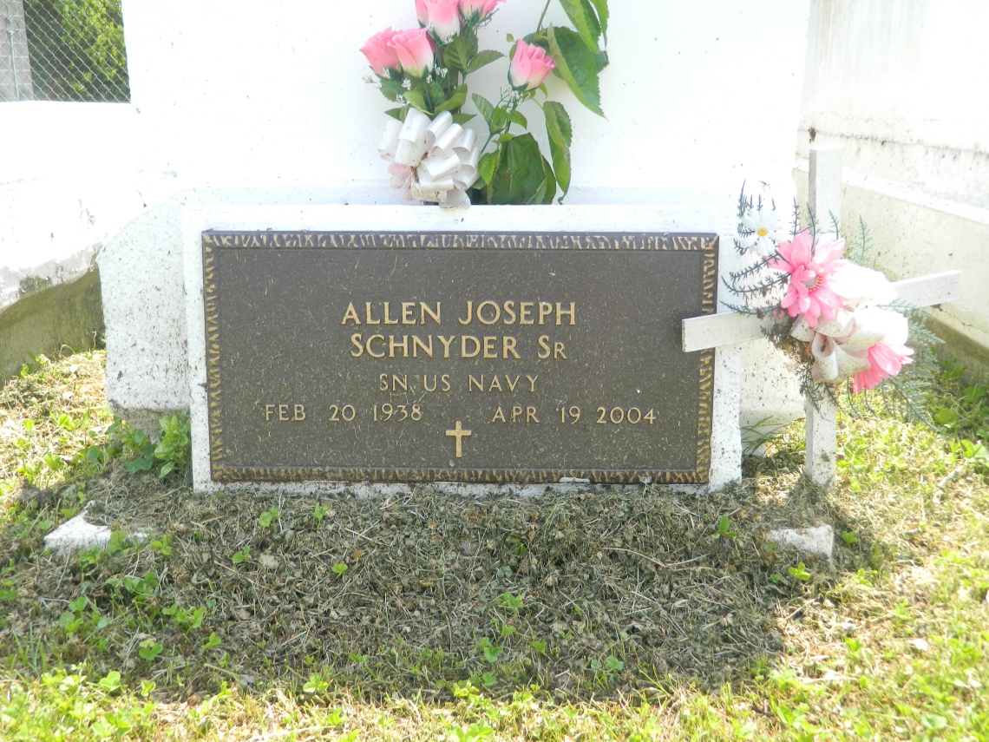

Allen "Speck" Schnyder Sr., a security guard, died Monday of a heart attack at his home. He was 66. Mr. Schnyder was a lifelong resident of Reserve. He was a deacon at Providence Baptist Church and a Navy veteran. Survivors include his wife, Shirley James Schnyder; three sons, Allen Schnyder Jr. and Damian and Darren Schnyder; two daughters, Tonia Schnyder of LaPlace and Andreana Connor; a stepson, Aubrey Schnyder; a foster son, Ky Wilson; four brothers, Nicholas Schnyder of North Carolina, Gregory and Ronald Schnyder of LaPlace, and Paul Schnyder Sr.; two sisters, Evangeline Johnson of LaPlace and Marjorie Finks of Las Vegas; and 14 grandchildren.

A funeral will be held Saturday at 11 a.m. at Providence Baptist Church on River Road in LaPlace. Visitation will begin at 9 a.m. Burial will be in Providence Rest Haven Cemetery. Hobson Brown Funeral Home is in charge of the arrangements.

Times-Picayune, The (New Orleans, LA) - Friday, April 23, 2004

Contributed by Jane Edson