Nathan Clarence Smith

December 30, 1925 – November 20, 2011

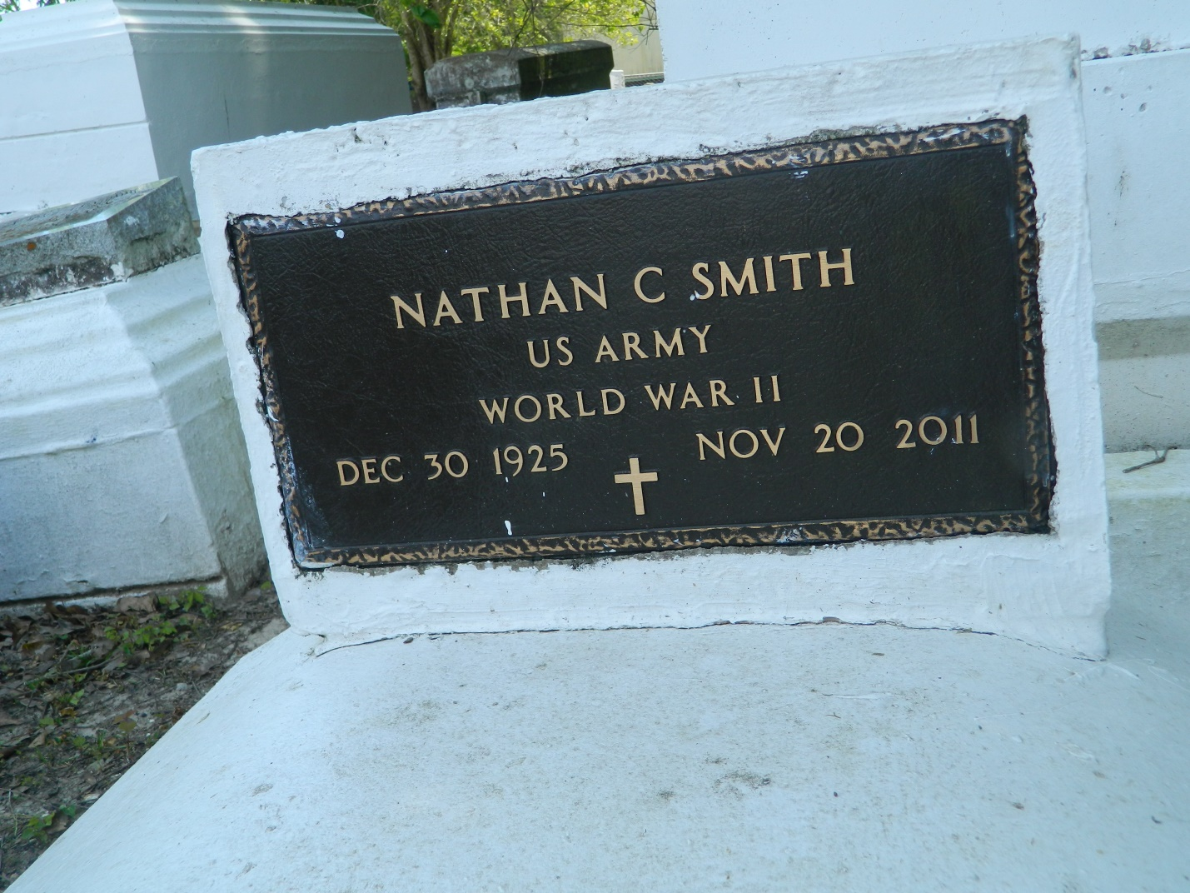

Clarence Nathan Smith departed this life on Sunday, November 20, 2011, in LaPlace, La. Father of Monica Zeno, Spencer, Nathan, Kevin, Amy and Patricia Smith. Also survived by a host of 4 generations of grand-children. Age 85.  
  
Funeral Services on Saturday, November 26, 2011 at 12:00 noon at Rising Star B.C., 620 Cardinal St., LaPlace, La. Rev. Donald August Pastor. Burial in Providence Rest Haven Cemetery. Visitation from 10:00 a.m. until service time.  
  
Services Entrusted to Hobson Brown Funeral Home, Garyville, La 70051, (985) 535-2516

Times-Picayune, The (New Orleans, LA) - Friday, November 25, 2011

Contributed by Jane Edson