Charles Stemley

Abt. 1942 - October 6, 2020

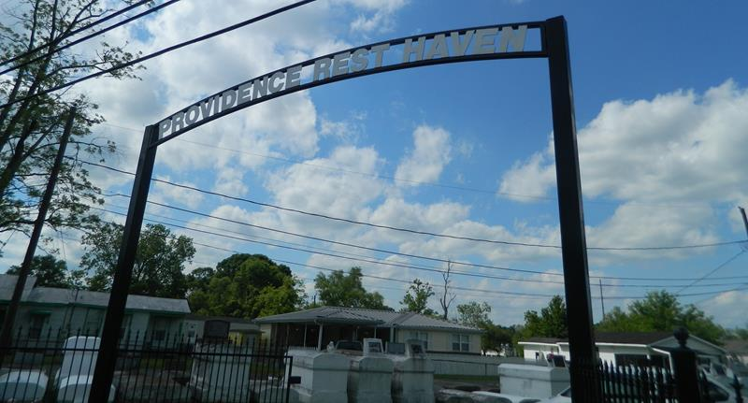

Charles Stemley, Age 78, departed this life on Monday, October 6, 2020. Son of the late Lillie and Herbert Stemley Sr., father of Charlene (Bruce) Young, Sandra (Lori) Chopin, Bernell, Michael, Dwayne (Eurika) and Charles (Denise) Stemley, Jr., Grandfather of Renika Banks, Dequincy, Dwayne Jr., Darion, Bernice, Louis, Deshawn, Bernell Jr, Brittany, Angela, Jordan and Biankia Stemley, and the late Martine Stemley, Brother of Leroy, Pearl, Lillie Mae, Evelyn, Barbara, Raymond (Ethel) Stemley and Florence S (Jimmie) Jessie. A devoted friend Sheila Williams. Charles is also survived by a host of nieces, nephews, other relatives and friends. Home-going Service on Saturday, October 17, 2020 at Providence B.C., 240 Pine St. Laplace, La at 1:00 pm. Rev. Willie Smith Pastor, walk-through Visitation on Friday October16, 2020 at Milesville Memorial C.O.G.I.C, 129 Apple St., Laplace, La from 5-7 p.m. (ONLY) Interment Providence Rest Haven Cemetery, Laplace, La. DUE TO CDC (COVID19) RESTRICTING SEATING IS LIMITED TO IMMEDIATE FAMILY (ONLY) MASK AND SOCIAL DISTANCING ARE REQUIRED. Professional Services entrusted to the Caring Staff of Hobson Brown Funeral Home 134 Daisy St. Garyville, La 70051, 985-535-2516.

Published in The Times-Picayune (New Orleans, LA) from Oct. 15 to Oct. 17, 2020.