Phillip Theriot

June 24, 1935 – July 29, 2010

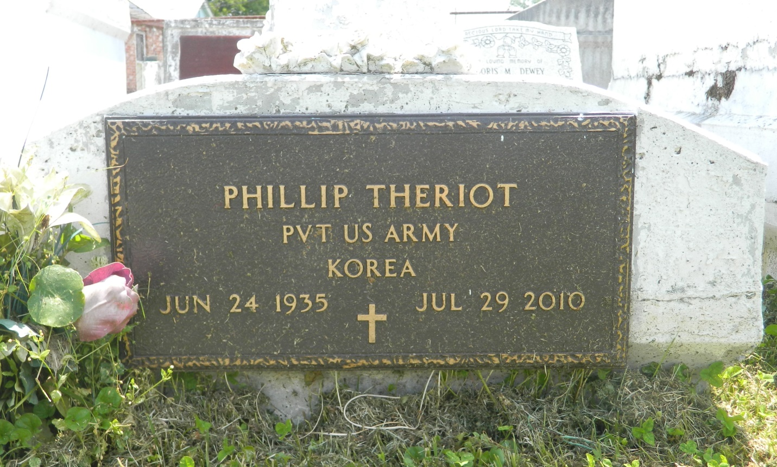

Phillip "Big Head" Theriot departed this earthly life and entered into eternal rest on Thursday, July 29, 2010 at Heritage Manor Nursing Home of Hammond, LA. Son of the late Joe and Florence Theriot. Beloved husband of Joyce Theriot of Laplace, LA. Loving father of Angelia "Lowery" Lennix, Brian Farlough, Mark Farlough, Kenisha Farlough and Garland Theriot. Brother of Mariah Narcisse of Laplace, LA. Also survived by 14 grandchildren, 2 great-grandchildren, a host of nieces, nephews, other relatives and friends. A native and resident of Laplace, LA.  
  
Relatives and friends of the family, also Pastors, Officers and Members of Providence #1 Baptist Church of Laplace, LA, employees of Wal-Mart Super Center, Perrilloux's Auto Repair and all neighboring churches are invited to attend the Funeral Services on Tuesday, August 3, 2010 at 11:00 AM at Providence #1 Baptist Church, 240 Pine St., Laplace, LA. Rev. Willie Smith officiating. Interment in Providence Cemetery of Laplace, LA. Visitation will be at the above named church from 9:00 AM until Service time.  
  
Bardell's Mortuary of Mt. Airy, LA in charge. Information: 985-535-6837

Times-Picayune, The (New Orleans, LA) - Monday, August 2, 2010

Contributed by Jane Edson