Rev. Raphield Warren Sr.

August 2, 1931 – May 23, 2002

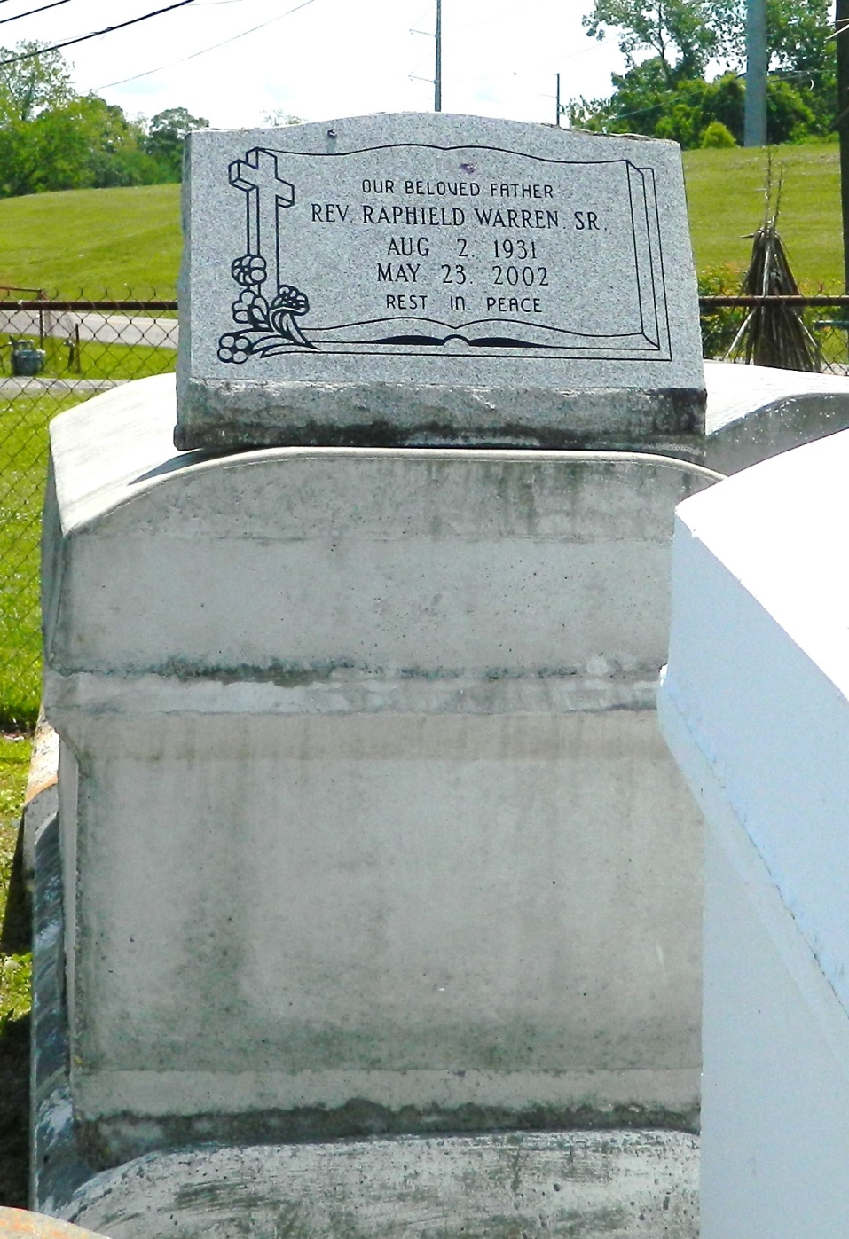

Rev. Raphield Warren, Sr. departed this life on Thursday, May 23, 2002, at 8:50 p.m. in LaPlace, La. Husband of the late Rosie Brumfield Warren. Father of Harold, Raphield, Jr., Adrian, Gary, and Annette Warren and Janet W. Orosco. Son of the late Mary Hoffman Warren and Bishop Joseph Warren, Sr. Brother of Evola Keller, Cloria Clark, Selina Paul, Mary Boatner, Rev. Samuel Warren, and Rev. Benjamin Warren, survived by 5 grandchildren and a host of daughters-in-law, sons-in-law, nieces, nephews, other relatives and friends. A native of Montz, La. and a resident of LaPlace, La. for may years. Age 70.  
  
Relatives and friends of the family, pastor, officers, and members of the Greater Morning Star B.C. and all neighboring churches, employees of International Matex-Tank Terminal, Delta Beverages, Elmwood Marine, Triangle Fleet, and Winn Dixie are invited to attend the funeral services on Wednesday, May 29, 2002, at 11:00 at the above named church, 1003 Balsam St, LaPlace, La. Rev. Samuel Warren officiating. Internment in Providence Rest Haven Cemetery, LaPlace, La. Visitation will begin at 10:00 a.m. until funeral time.  
  
Hobson Brown Funeral Home in charge of arrangements.

Times-Picayune, The (New Orleans, LA) - Tuesday, May 28, 2002

Contributed by Jane Edson