Robert Sterling

April 19, 1920 – July 21, 1999

Lorenza G. Watkins

June 17, 1906 – December 21, 2000

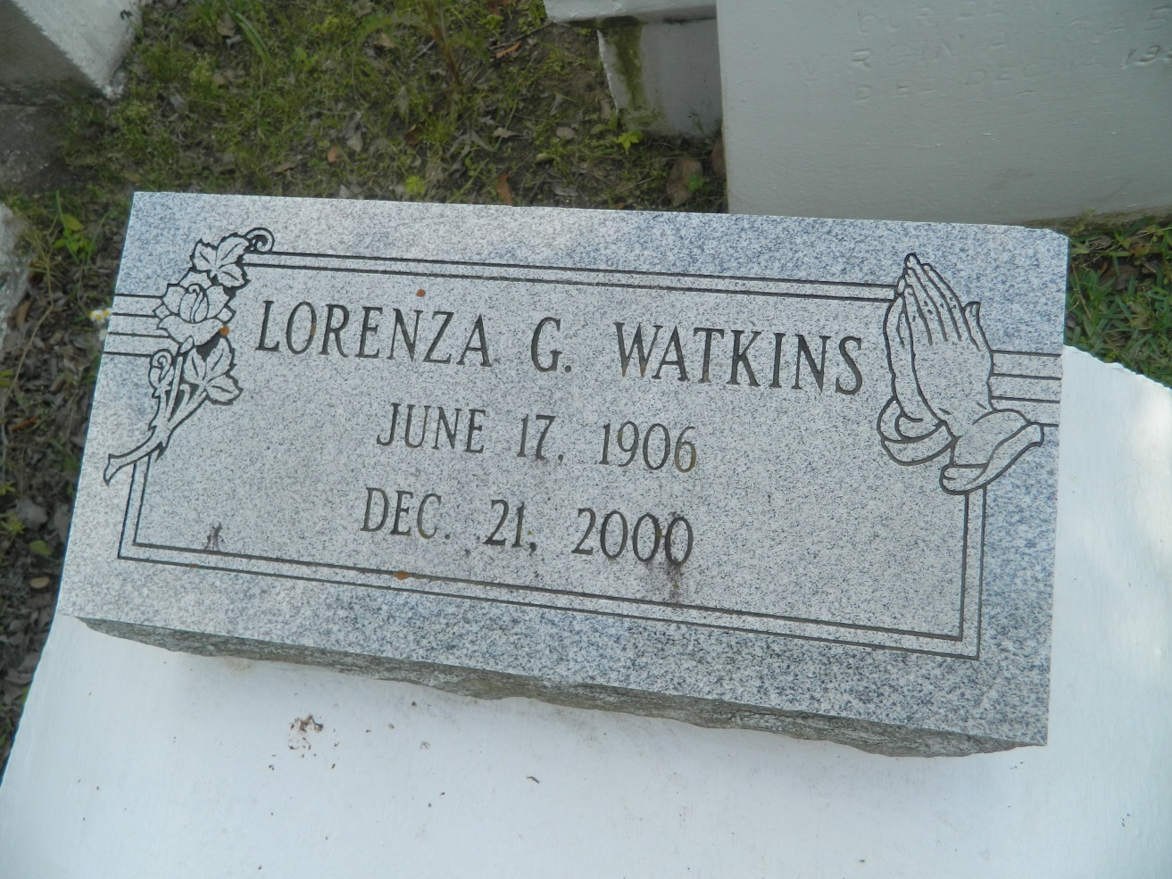

LAPLACE - Lorenza Watkins, 94, died Dec. 21.She was the wife of the late James Watkins, mother of Hilda Batiste, Clarence and Harold Watkins, Marion Ward and Barbara Julien of LaPlace, Audrey King of Violet, Betty Sonny of Baytown, Texas, Joyce Taylor of Poinciana, Fla., Cornealius Watkins of Harve. Services were held Dec. 26 at Providence Baptist Church No. 1 of LaPlace, with interment in the church cemetery.

L'Observateur, LaPlace, LA; December 27, 2000

Submitted for the LA GenWeb Archives by: Donald W. Johnson