Lorenza G. Watkins
June 17, 1906 – December 21, 2000

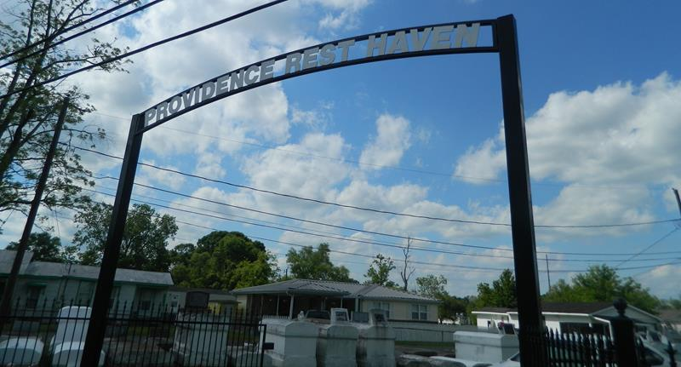

WATKINS LAPLACE – Lorenza Watkins, 94, died Dec. 21. She was the wife of the late James Watkins, mother of Hilda Batiste, Clarence and Harold Watkins, Marion Ward and Barbara Julien of LaPlace, Audrey King of Violet, Betty Sonny of Baytown, Texas, Joyce Taylor of Poinciana, Fla., Cornealius Watkins of Harvey, Nellie Farlough of Mt. Airy and the late Azelia Fobb and Nelson Watkins. Services were held Dec. 26 at Providence Baptist Church No. 1 of LaPlace, with interment in the church cemetery.

L’Observateur, LaPlace, Louisiana
Wednesday, December 27, 2000

